

Coffee, Cooperation and Competition:
A Comparative Study of Colombia and Vietnam

Authors:

Adriana Roldán-Pérez
Maria-Alejandra Gonzalez-Perez
Pham Thu Huong
Dao Ngoc Tien

Research assistants (Colombia):
Franz Xaver Riegler
Stephanie Riegler
Catalina Tabares
Melissa Eusse

Research assistant (Vietnam):
Nguyen Thu Hang
Table of contents

List of figures 4
List of tables 4
Acronyms, abbreviations and definitions 6
Weights and measures 6
Abstract 7
1 Introduction 8
1.1 Research objectives 9
1.1.1 General objectives 9
1.1.2 Specific objectives 9
1.2 Research methodology 9
2 Literature review on the global value chain (GVC) of coffee 11
2.1 Theory of global value chains 11
2.1.1 Introduction to the value chain concept 11
2.1.2 Global commodity chains 12
2.1.3 Value chain analysis 13
2.1.3.1 Definition 13
2.1.3.2 Methodological aspects of value chain analysis 15
2.1.4 Governance 15
2.1.5 Barriers to entry and rent 16
2.1.6 Upgrading in value chains 16
2.2 Overview of the world coffee market 17
2.2.1 World coffee production 17
2.2.2 Production by type of coffee 18
2.2.3 Coffee producing countries 19
2.2.4 Stocks in producing countries 20
2.2.5 World coffee exports 21
2.2.6 World coffee consumption 24
2.2.7 The International Coffee Organisation and coffee prices 29
2.2.8 Mapping the global value chain of coffee 31
3 Analysis of Colombia and Vietnam’s participation in the coffee value chain 33
3.1 Vietnam’s participation in the GVC of coffee 33
3.1.1 Background 33
3.1.1.1 Natural conditions 33
3.1.1.2 Infrastructure 34
3.1.1.3 Policy and legal frameworks 35
3.1.2 Vietnam’s position in the global coffee market 36
3.1.2.1 Export output 37
3.1.2.2 Export turnover 37
3.1.2.3 Export product structure 38
3.1.2.4 Export prices 39
3.1.2.5 Export markets 40
3.1.3 Actors 42
3.1.3.1 Farmers 42
3.1.3.2 Middlemen 43
3.1.3.3 Processing or exporting companies 44
3.1.3.4 Vietnam’s instant coffee market 44
3.1.3.5 Other players 45
3.1.3.5.1 The Vietnam Coffee and Cocoa Association 45
3.1.3.5.2 Buon Ma Thuot Coffee Exchange Centre 46
3.1.4 Case studies of coffee companies in Vietnam 46
3.1.4.1 Case study one: Vinacafe Buon Ma Thuot 46
3.1.4.2 Case study two: Phuong Vy Coffee Company 50
3.2 Colombia’s participation in the GVC of coffee 53
3.2.1 Colombia’s coffee industry 53
3.2.1.1 Natural conditions 53
3.2.1.2 Infrastructure 54
3.2.1.3 Regulatory framework 56
3.2.2 Position in international markets 56
3.2.2.1 Coffee production 56
3.2.2.2 Coffee exports 58
3.2.2.3 Domestic coffee consumption 59
3.2.2.4 Actors 60
3.2.2.4.1 Coffee growers 60
3.2.2.4.2 National Federation of Coffee Growers of Colombia 61
3.2.2.4.3 Coffee processors 61
3.2.2.4.4 Coffee exporters 62
3.2.2.4.5 The state 63
3.2.3 Internationalisation and market innovation 64
3.2.4 Case studies of coffee companies in Colombia 66
3.2.4.1 Case study one: National Federation of Coffee Growers 66
3.2.4.2 Case study two: Colcafé S.A. 67
3.2.5 Colombia’s participation in the GVC of coffee 69
3.3 Comparative analysis of Vietnam and Colombia’s participation in the GVC of coffee 71
3.3.1 Coffee industry environment 71
3.3.2 Position in global markets 72
3.3.2.1 Coffee exports 72
3.3.2.2 Domestic coffee consumption 73
3.4 The participation of Vietnam and Colombia in the GVC of coffee 74
4 Conclusions and recommendations 75
4.1 Cooperation and competition between Colombia and Vietnam 79
4.2 Recommendations to Colombia 82
4.3 Recommendations to Vietnam 83
Appendix: developed research instrument 84
References 88

List of figures

Figure 1: Porter’s (1985) representation of a value chain 11
Figure 2: Coffee producing countries 18
Figure 3: World coffee exports by value and by volume, 1996/97-2007/08 21
Figure 4: World coffee consumption, 2002/03-2006/07 24
Figure 5: Coffee consumption in importing countries/regions, 2002/03-2006/07 26
Figure 6: ICO composite price 29
Figure 7: Value added created at each stage of the coffee GVC 32
Figure 8: The global value chain of coffee 32
Figure 9: Vietnam’s coffee-growing area 33
Figure 10: Vietnam’s coffee exports by value and by volume, 1995-2007 38
Figure 11: Export price of Vietnamese coffee, 1995-2007 39
Figure 12: Export markets for Vietnamese coffee 41
Figure 13: Vietnam’s participation in the GVC of coffee 41
Figure 14: Domestic value chain of Vinacafe Buon Ma Thuot 47
Figure 15: Vinacafe Buon Ma Thout’s participation in the GVC of coffee 49
Figure 16: Vinacafe Buon Ma Thuot’s costs and profits 50
Figure 17: Phuong Vy as a wholesaler and as a roaster 51
Figure 18: Phuong Vy’s external relations 52
Figure 19: Coffee production and exports in Colombia, 1980-2007 57
Figure 20: Colombian national production of instant, roasted and ground coffee 57
Figure 21: Coffee exports as a percentage of Colombia’s total and agricultural exports, 1991-2006 58
Figure 22: Colombian coffee exports, 1994-2007 59
Figure 23: Domestic coffee consumption in Colombia, 2003-2007 60
Figure 24: Market share of roasted coffee by Colombian companies, 2008 62
Figure 25: Market share of Colombian companies in the instant coffee market, 2008 62
Figure 26: Percentage of market share of coffee exporters in Colombia, 1993-2007 63
Figure 27: Types of speciality coffee from Colombia 65
Figure 28: Structure of the NFC 66
Figure 29: Colombian’s participation in the GVC of coffee 69

List of tables

Table 1: World coffee production by type, 2002/03-2007/08 19
Table 2: Coffee producing countries 19
Table 3: Stocks in producing countries by type, 2003/04-2007/08 20
Table 4: World coffee exports, by value and volume, 1996/97-2007/08 21
Table 5: Overview of world coffee exports by type, 2002/03-2006/07 23
Table 6: Volume and value of exports by group of coffee 24
Table 7: Consumption in importing countries/regions, 2002/03-2006/07 25
Table 8: Domestic consumption in coffee producing countries, 2007/08 27
Table 9: Per capita coffee consumption in main importing countries 27
Table 10: Per capita coffee consumption in main producing countries 28
Table 11: Concentration of MNCs in the international coffee industry, 2006 28
Table 12: ICO indicators price, annual average, 2001-2008 30
Table 13: Export output and turnover of Vietnamese coffee 37
Table 14: Vinacafe Buon Ma Thuot’s coffee export quantity and turnover 48
Table 15: Vinacafe Boun Ma Thout’s share of the coffee export market, 2001-2007 48
Table 16: Classification of coffee beans by size 49
Table 17: Coffee production in terms of the relationship between total area sown and the size of the holding 55
Table 18: Number of coffee threshing machines in Colombia, 2004-2008 55
Table 19: Number of coffee roasters in Colombia, 2004-2008 55
Table 19: Main markets for Colombia coffee 59
Table 20: Per capita coffee consumption in main producing countries, 2001-2005 60
Table 21: Comparison of Colombia and Vietnam’s coffee industries using the observation protocol 75

Acronyms, abbreviations and definitions

BCEC: Buon Ma Thuot Coffee Exchange Centre
BMT: Boun Ma Thuout
Coffee year: ICO accounting period from 1 October to 30 September
EU: European Union
FOB: Free on board
Green coffee bean: coffee in the naked bean form before roasting
GBE: Green bean equivalent
GVC: Global value chain
ha: Hectare
HACCP: Hazard Analysis and Critical Control Points
HCM City: Ho Chi Minh City
ICO: International Coffee Organisation
idem: the same as previous (of reference)
ISO: International Organisation for Standardisation
ITC: International Trade Centre
MADR: Ministry of Agriculture and Rural Development of Colombia
MNC: Multinational corporation
NFC: The National Federation of Coffee Growers of Colombia
R&D: Research and development
USD: US dollars
VCA: Value chain analysis
VICOFA: The Vietnam Coffee and Cocoa Association
VND: Vietnamese dong

Weights and measures

1 bag of coffee = 60 kilogram = 132.3 pound
1 ton = 16.67 bags
1 ton = 1,000 kilogram
1 hectare = 10,000 m²
Abstract

This cross-country study compares two of the major coffee export-oriented countries (Colombia and Vietnam) in terms of:

- Infrastructure;
- Players: roles and reactions to external shocks;
- Technology adoption at different stages of production;
- Added value;
- Positioning in both domestic and global markets;
- Internationalisation patterns;
- Marketing and branding innovation;
- Regulatory frameworks and policy environment.

Using value chain analysis as its primary methodology, this research identifies links and dynamics in the value chain in both Colombia and Vietnam that have been developed in their respective coffee industries in order to improve competitiveness, increase sustainability and respond to market demands.

This study also explores considerations at the production, policy making and marketing levels towards satisfying niche markets, such as speciality coffees and responsible trade in social, labour and environmental terms. Furthermore it identifies current patterns of cooperation and competition threats between these two countries.

Both countries can compete as long as both produce a large enough quantity of coffee. Competition is allowed by the fact that coffee roasters are willing to substitute Arabica beans for Robusta beans, as well as the willingness of consumers to buy and drink coffee blends. Nevertheless, cooperation between both countries can also be achieved, by focusing on consumer preferences. Cooperation could also be achieved through the creation of a campaign that aims to educate coffee consumers.
1 Introduction

This cross-country study aims to compare two of the major coffee export-oriented countries (Colombia and Vietnam) in terms of:

- Infrastructure;
- Players: roles and possible reactions to external shocks;
- Technology adoption at different stages of production;
- Added value;
- Positioning in both domestic and global markets;
- Internationalisation patterns;
- Marketing and branding innovation;
- Regulatory frameworks and policy environment.

Using value chain analysis as its primary methodology, this research identifies links and dynamics in the value chain in both Colombia and Vietnam that have been developed in their respective coffee industries in order to improve competitiveness, increase sustainability and respond to market demands. This paper is aimed at companies, mid-level institutions and governments, which may in particular benefit from its findings.

This study also explores considerations at the production, policy making and marketing levels towards satisfying niche markets, such as speciality coffees and responsible trade in social, labour and environmental terms. Furthermore it identifies current patterns of cooperation and competition threats between these two countries.
1.1 Research objectives

1.1.1 General objectives

- To develop a methodology for comparative studies amongst developing countries in different agricultural sectors, and contribute to the understanding of socio-economic context and processes linked to the coffee industry in terms of development.

1.1.2 Specific objectives

- To identify links and dynamics in the value chain in both Colombia and Vietnam that have been developed in their respective coffee industries in order to improve competitiveness, increase sustainability and respond to market demands.

- To explore considerations at the production, policy making and marketing levels towards satisfying niche markets, such as speciality coffees and responsible trade in social, labour and environmental terms.

- To identify current patterns of cooperation and competition threats between these two countries.

- To explore the context, players, stages and features which explain the differences between Colombia and Vietnam.

- To design a research instrument that will potentially be used in other coffee-producing countries, and for other agricultural commodities.

- To share expertise and knowledge in areas such as: the coffee industry, development strategies and value chain methodology.

- To inform teaching on international development-related areas.

- To compare development policies in both countries and identify regulatory mechanisms which facilitate economic and social sustainability in the coffee industry.

1.2 Research methodology

In order to compare the coffee industries in Vietnam and Colombia, both primary and secondary data sources were used. Data from various sources on the coffee industry was collected in both Colombia and Vietnam. Secondary data included company and industry reports, books, academic papers, articles, databases, and websites related to the coffee industry in both countries. Since there is no evidence of a previous comparative study of Vietnam and Colombia, the research was designed to mainly focus on the collection of primary data in both countries. Value chain analysis (Dolan and Humphrey 2000; Gereffi 1999; Gereffi, Humphrey and Sturgeon 2005; Gereffi and Kaplinski 2001; Humphrey and Schmitz 2001; Kaplinsky 2000; Kaplinsky and Morris 2000; Sturgeon 2000) was chosen as the methodology with which to select the sample, and to design an observation protocol, which was the main research instrument of this survey. This observation protocol serves as a detailed guide for non-structured interviews, and as a checklist of key aspects to be observed. It is critical to mention that the instrument needed to be flexible in order to adapt to different types of research participants, and different geographical locations.

The observation protocol was based on both literature on the coffee industry and secondary data. The initial version of the protocol consisted of a list of categories to be observed. This list went through a rigorous process of being refined and complemented during the study. The instrument is included at the end of this report.

Field trips were conducted in both Colombia and Vietnam. In-depth interviews with key players in both coffee industries were selected. These research participants included general directors, managing directors, export executives, marketing executives and farmers from coffee manufacturers, export companies and coffee growers’ associations. The fieldwork in Colombia was conducted in the Antioquia coffee region and in Medellin between October 2008 and January 2009. The fieldwork in Vietnam took place during February 2009 in Hanoi, Hochiminh and Buonmethuot.

Research participants constituted a selective sample that aimed to represent each aspect of the value chain.

The objective of the fieldwork was to find out (i) the main features of the coffee industry in each country; (ii) the differences between the coffee industry in each country; and (iii) the participation of each player and each country in the global coffee value chain.

Immediately after the fieldwork, a process of data analysis took place. The observation protocol and its categories served to guide the qualitative analysis phase of this research. From the data analysis, two case studies were written for each country to illustrate in further detail the participation of specific players in the value chain. Although, this research has limitations in terms of geographical scope (it did not sample all the coffee regions in both countries, and it did not interview all the main players of the industry), it certainly provides a comparative overview of the coffee industry in both countries which was previously unavailable. It is expected that the same methodology and the same research instrument could be used to compare other coffee producing countries.
2 Literature review on the global value chain (GVC) of coffee

2.1 Theory of global value chains

2.1.1 Introduction to the value chain concept

As a starting point it is important to outline the value chain concept. According to Michael Porter, a value chain “disaggregates a firm into its strategically relevant activities in order to understand the behaviour of costs and the existing and potential sources of differentiation” (Porter 1985). This value chain allows us to diagnose the competitive advantage of a firm or industry and to enhance this advantage by tailoring the value chain (Porter 1985). Nevertheless, the value chain concept has evolved over the years since Porter’s definition.

In the narrow meaning, a value chain includes the range of activities performed within a firm to produce a certain output. It refers to the work by Porter (1985) on competitive advantages. Porter (1985) utilised the framework of value chains to assess how a firm should position itself in the market and in relation to suppliers, buyers and competitors.

Figure 1: Porter’s (1985) representation of a value chain

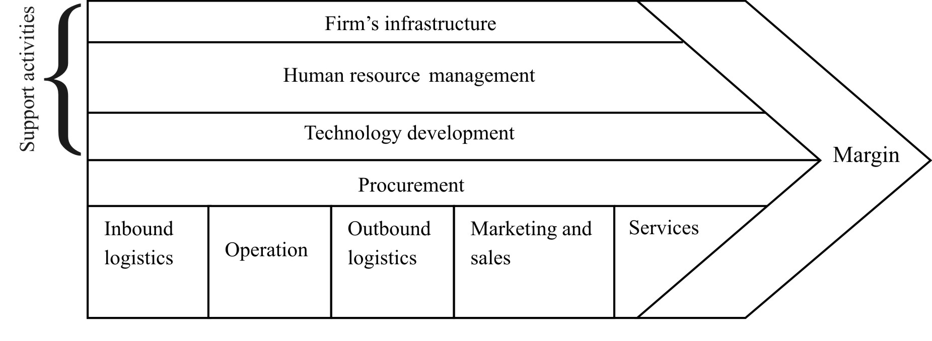
Source: Porter (1985)

The ‘broad’ approach to value chains looks at the complex range of activities implemented by various actors (primary producers, processors, traders, service providers, etc.) to deliver a raw material to retail of the final product. The ‘broad’ value chain starts from the production system of the raw materials and moves along the linkages between enterprises engaged in trading, assembling, processing, etc. This broad approach does not only look at the activities implemented by a single enterprise. Rather, it includes all its backward and forward linkages, up until the level at which the raw material produced is linked to the final consumer.

In a more contemporary sense, a ‘simple’ value chain could be defined as the description of a full range of activities necessary to carry a product or service from conception, through the various production stages (including physical transformation and other producer services), distribution to the final consumer, and removal after its use. Nonetheless, in real life applications, value chains tend to be more complex, involving several producers, creating manifold links within the value chain. Therefore it can appear that one value chain may be composed of several smaller value chains (Kaplinsky and Morris 2001).

In the context of globalisation, the word fragmentation is used to depict the physical separation of the elements of the production process, considering the international separation of production as a new phenomenon (Arndt and Kierkowski 2001). According to Feenstra (1998) this “disintegration of production” is highly connected with the “integration of trade” in the global economy. Indeed, Brulhart (2008) estimates that 44 per cent of global trade is intra-industry.

As noted by Korzeniewicz and Smith (2000), relative political progress and the institutional configurations of a state and structural forces are necessary to profit from globalisation. However, the distribution of the income generated by globalisation is not even among the countries that participate in the value chain. Thus countries may increase their participation in global trade but experience a decline in their relative share of income (Kaplinsky 2000).

2.1.2 Global commodity chains

A commodity chain is “a network of labour and production processes whose end result is a finished commodity” (Hopkins and Wallerstein 1986, p. 159). True commodity chains may be defined as those in which basic agricultural products are grown, processed and marketed. These are usually driven by commodity traders (Gibbon 2001). Nevertheless, a commodity chain may also be buyer- or producer-driven (Gereffi 1994).

The global commodity chain (GCC) concept was developed by Gereffi in the 1990s, and attached the value-added chain concept to the global organisation of industries (Gereffi and Korzeniewicz 1994). The value-added chain refers to “the process by which technology is combined with material and labour inputs, and then processed inputs are assembled, marketed and distributed” (Kogut 1985, p. 15). In this context, a firm may constitute one link or be vertically integrated (Kogut 1985).

Global commodity chains are an analytical approach to understanding the mechanisms of trade. This approach was developed primarily for the analysis of industrial commodities from production to consumption. Gereffi (1994) defines GCCs as “systems that give rise to particular patterns of coordinated international trade, rooted in transnational production systems” (Gereffi 1994, p. 215). They have three dimensions: (a) input-output structure, (b) territoriality and (c) governance. The idea of GCCs was first introduced by Hopkins and Wallerstein (1986), who referred to them as “a set of inter-organisational networks clustered around one commodity or product, linking households, enterprises, and states to one another within the world-economy” (Gereffi, Korzeniewicz and Korzeniewicz 1994, p. 2).

Supply chains are central to the GCC analysis. Urminsky (2005) identifies three unequal relationships in supply chains: first, between buyer and supplier, which in general favours multinational companies, with suppliers having little chance to negotiate their contracts and constantly being pressured to cut costs; second, between management and workers; and third, between states and multinational corporations (MNCs), expressed in the tendency of MNCs to displace the state and assume the role of labour inspectors through the adoption of private mechanisms.

A variation, the filière (chain) tradition, was developed by researchers at the French National Institute for Agricultural Research (INRA) and the French Agricultural Research Centre for International Development (CIRAD) as an analytical tool applied mostly to agricultural commodities such as rubber, cotton, coffee and cocoa, generally in francophone Africa (Raikes et al. 2000). The filière approach, rather than a theory, is a practical tool of analysis for applied research (Raikes et al. 2000) focussing on the technical side of commodity flows. It does not focus on the role of social actors within the chain.

Producer-driven commodity chains are defined by Gereffi (1994) as those industries in which MNCs or other large integrated industrial enterprises control the production system, and control is exercised from their administrative headquarters (Gereffi 1994; Humphrey 2003; Sturgeon 2002). In producer-driven commodity chains, barriers to entry are determined by capital and technology within production, and by the ability to coordinate top-down and bottom-up linkages between suppliers and retailers.

Buyer-driven commodity chains refer to those industries in which brand-name merchandisers, trade companies and retailers have a central role in decentralised production networks in a diverse range of exporting countries, generally located in developing countries (Gereffi 1994, p. 216).

In other words, buyer-driven commodity chains operate in a more decentralised way than producer-driven commodity chains, and they are a result of a global trend towards geographic expansion and integration of distribution, marketing and consumption (Korzeniewicz, 1995). Particularly in the case of speciality coffees and increased quality demands from the buyer, there can be a strong control element, i.e. that many things are prescribed by the buyer.

Buyer-driven commodity chains are dependent on brands and marketing for market entry. Therefore, brand value and the consolidation of brands in consumer markets play a critical role (Gereffi, 1994).

2.1.3 Value chain analysis

2.1.3.1 Definition

Value chain analysis (VCA), or commodity chain analysis, disaggregates the global structure of fabrication, trade and consumption of commodities and allows for the identification of actors and geographical divisions (Tuvhag, 2008).

Firstly, at its most basic level, a VCA systematically maps the actors participating in the production, distribution, marketing and sales of a particular product (or products). This mapping assesses the characteristics of actors, profit and cost structures, and flows of goods throughout the chain, as well as employment characteristics and the destination and volumes of domestic and foreign sales (Kaplinsky and Morris 2001). Such details can be gathered from a combination of primary survey work, focus groups, informal interviews and secondary data.

Secondly, VCA can play a key role in identifying the distribution of benefits to different actors in the chain. That is, through the analysis of margins and profits within the chain, one can determine who benefits from participation in the chain and which actors could benefit from increased support or organisation. This is particularly important in the context of developing countries (and agriculture in particular), given concerns that the poor are particularly vulnerable to the process of globalisation (Kaplinsky and Morris, 2001). One can supplement this analysis by determining the nature of participation within the chain to understand the characteristics of its participants. The distribution of benefits between actors is explained by a number of factors; the VCA focuses on the dynamics of rent, and thereby transcends different economic branches and sectors. Through a full view of the whole chain the “rent-rich activities” can be traced with greater ease. Besides, the global focus of VCA accounts for the global dynamics of returns, not only on a national level. This allows for the identification of opportunities to increase income more accurately than analysis at a purely national level would (Kaplinsky 2000).

Thirdly, VCA can be used to examine the role of upgrading within the chain. Upgrading can involve improvements in quality and product design that enable producers to gain higher value, or through diversification in the product lines served. An analysis of the upgrading process includes an assessment of the profitability of actors within the chain as well as information on current constraints. Governance issues play a key role in defining how such upgrading occurs. In addition, the structure of regulations, entry barriers, trade restrictions and standards can further shape and influence the environment in which upgrading could take place.

Finally, VCA can highlight the role of governance in the value chain. Governance in a value chain refers to the structure of relationships and coordination mechanisms that exist between its various actors. Governance is important from a policy perspective for identifying the institutional arrangements that may need to be targeted to improve capabilities in the value chain, remedy distributional distortions, and increase value added in the sector. Here a distinction is made between two types of governance: those cases where the coordination is undertaken by buyers (‘buyer-driven commodity chains’) and those in which producers play the key role (‘producer-driven commodity chains’).

Value chain analysis has three key elements: (a) barriers to entry and rent, (b) governance, and (c) systemic efficiency (as opposed to point efficiency, meaning that the links of the complex value chain need to be integrated to make them efficient) (Kaplinsky 2000). Barriers to entry and rent as well as the governance factor are explained in more detail in sections 2.1.4 and 2.1.5 below.

2.1.3.2 Methodological aspects of value chain analysis

There are several methodological aspects that have to be taken into account when undertaking value chain analysis (Kaplinsky and Morris 2001). First, the adequate point of entry must be chosen, as it defines the chain or chains that is or are the subject of the analysis in accordance with the objective of the study (Kaplinsky and Morris 2001).

Product positioning and key success factors in final markets are aspects of high importance, as global markets show key characteristics (or critical success factors) that are derived from their segmentation. Another methodological feature to take into account is the question of how the producer gains access to the final market. It is therefore necessary to identify the key buyers of a determined chain and the dynamics of the buying function, in order to identify the critical success factors of the market (Kaplinsky and Morris 2001).

Benchmarking production efficiency is another aspect tied to the methodology of VCA, where the efficiency of the different parties of the value chain is measured. The governance of the value chain is a critical aspect, where the rules that govern the value chain are identified. Another important feature is upgrading. Upgrading is discussed in more detail in section 2.1.6. At this point it is important to highlight that upgrading practices and performance needs to be analysed and recorded for VCA (Kaplinsky and Morris 2001).

Finally, distributional issues have to be analysed, not just competitiveness issues. Distribution has both power and income components. In this context the different types of rents and barriers to rent have to be analysed, the unit of account of the variables in question has to be determined, as well as the circumstances under which the value added and the turnover data are illustrative for the analysis. It also has to be determined whether profits are the adequate measure for distribution and how the distribution of skills can be incorporated into the analysis. The local, national and global dimensions, the decomposition of the income streams and the presence of small and medium sized enterprises have to be taken into account (idem) as well.

2.1.4 Governance

As explained by Gereffi (1994), governance in value chains refers to the existence of key actors inside the chain, which are responsible for the division of labour between the firms, and for the capacities of individual participants to upgrade their operations or functions.

According to Dolan and Humphrey (2000), there are two factors that explain why a commodity chain should be governed. First, the increased employment of product differentiation strategies in developed country markets indicates that retailers obtain competitive advantage when they sell non-standardised products that are not commonly available in the market. Therefore the competition is not only based on price but on reliability, product assortment, product quality and innovative speed, among others. This competitive strategy leads to an increased need for supply chain governance (Dolan and Humphrey 2000).

The second factor states that when developing country producers have difficulties in meeting the requirements of developed country markets an increase in value chain governance is necessary (idem). These difficulties arise because the products made in developing countries differ from the equivalent products in developed markets. Therefore, the producers need to acquire information about developed markets in order to adapt their products (Keesing and Lall 1992).

Gereffi, Humphrey and Sturgeon (2005) developed a theory of value chain governance, based on three factors: “(a) the complexity of information and knowledge transfer required to sustain a particular transaction; (b) the extent to which this information can be codified and, therefore, transmitted efficiently and without transaction-specific investment between the parties to the transaction; and (c) the capabilities of actual and potential suppliers in relation to the requirements of the transaction” (Gereffi et al. 2005, p. 85).

However, governance differs depending on the type of value chain. In producer-driven chains, governance is exercised by the companies that control the key technology and production facilities. On the contrary, in buyer-driven chains, the key governance functions are exercised by the retailers and the brand name companies (Gereffi 2004).

2.1.5 Barriers to entry and rent

Initially, rent, in its economic sense, was described as the payment made by a farmer to the owner of the land as contribution for being allowed to use the land (Ricardo 1817), with focus on the natural scarcity of land rather than its differential fertility. But, as Kaplinsky (2000) explained, in the case of VCA, economic rent is considered to arise from differential productivity factors and barriers to entry (which can be interpreted as scarcity). In addition, economic rent is not only derived from natural scarcity but from purposive action by the producers (Kaplinsky 2000).

Barham, Bunker and O’Hearn (1994) identify two types of rent: ‘resource’ and ‘strategic’ rent. Resource rent refers to rent paid to the owners of scarce resources. On the other hand, strategic rent is only paid when the resource holder or any other economic agent can push the price above the competitive price.

The increasing capabilities of countries in industrial terms have caused the reduction of entry barriers and therefore increased competitive pressures on value chains (Kaplinsky 2000).

2.1.6 Upgrading in value chains

According to Fitter and Kaplinsky (2001), globalisation has forced producers to upgrade their production, for manufactured as well as primary products, through differentiation of their products. Gereffi (1999) defines upgrading in value chains as the process by which industries in developing countries obtain new skills through export manufacturing and create links with new commodity chains that can use these skills (Gereffi 1999).

Upgrading can also be seen as innovating in order to receive increased added value (Gereffi 1999). However, upgrading is not the same as innovation. In order to upgrade, the speed of innovation relative to the competition has to be taken into account (Kaplinsky and Morris 2001).

Upgrading can occur at the process, product, functional or intersectoral level (Giuliani and Bell 2005). Product upgrading refers to moving into more refined product lines with increased value added. Process upgrading involves transforming inputs into outputs with increased efficiency by reorganising the production process or using superior technology (Gwynne 2008). Regarding functional upgrading, the firm moves along the value chain in order to realise a function different from that previously. Finally, intersectoral or chain upgrading refers to the movement of the firm from one sector into another so that it participates in several value chains (Giuliani and Bell 2005).

For primary commodities, according to Gibbon (2001), non-volume-related upgrading (quality upgrading) can be realised either by capturing higher margins for unprocessed commodities by improving the quality of the product, or by producing new forms of existing commodities. Nevertheless, in practice, upgrading in global commodity chains exhibit practical difficulties and complexities (Gibbon 2001).

2.2 Overview of the world coffee market

2.2.1 World coffee production

Coffee is the second most traded commodity in the world after oil. The first coffee plantations were originally established in Ethiopia and the Arabian Peninsula. Coffee was introduced to Asia and, later, to Latin America by the Dutch, who became the main suppliers of coffee to Europe in the 18th century. Today it is widely grown throughout tropical regions (ITC 2008). Most of the world’s green coffee beans are produced in Latin America and in particular in Brazil, which has led world production since 1840. In 2006 more than half of global coffee production was concentrated in three countries: Brazil, Vietnam and Colombia (Roldán-Pérez 2007).

Despite being an essential commodity for many economies since the 19th century, producers, consumers and retailers have been concentrated in only a few countries. The world production of coffee is quite volatile and is extremely vulnerable to weather conditions. Although in 1976/1977 world coffee production decreased due to the Brazilian drought, it has grown steadily since 1980, increasing from 80.7 million bags in 1980/1981 to 123.4 million bags in 2007/2008 (ITC 2008; ICO 2008).

Brazil is the world’s largest coffee producer and exporter. Vietnam expanded its production rapidly throughout the 1990s and now holds the number two position, displacing Colombia into third place and Indonesia into fourth. In 1976, eight countries shared 60 per cent of world coffee production (Brazil, Colombia, Cote d’Ivoire, Ethiopia, Indonesia, Mexico, Uganda and El Salvador) but with the rise of Vietnam as the second largest coffee producer in 1999, just four countries (Colombia, Brazil, Vietnam and Indonesia) produced 60 per cent of the world’s coffee (Roldán-Pérez 2007).

Coffee is produced in more than 70 developing countries, while 45 countries are responsible for over 97 per cent of world output. Figure 2 shows the distribution of coffee growing areas across the tropics, with Asia, Africa and Latin America sharing 25.5 per cent, 12.6 per cent and 61.9 per cent of production respectively.

Figure 2: Coffee producing countries

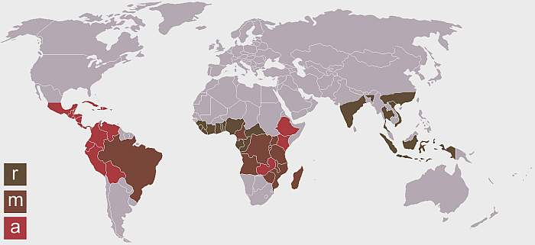
Source: http://www.coffeebeans.ie/about-coffee-page34052.html.
Notes: r: Robusta; a: Arabica; m: both Robusta and Arabica.

2.2.2 Production by type of coffee

Coffee is a seasonal crop and has been treated as a homogeneous commodity. However, seasons vary from country to country, starting and finishing at different times throughout the year and so do the different types of green coffee beans. Actually, there are many types of coffee produced within the same country but almost all commercial coffees come from two types of coffee: Arabica and Robusta. Arabica is grown at altitudes over 1,000m; it is characterised by its good aroma, taste, better quality and higher price, and generally represents 65 per cent of world coffee production. Robusta beans can grow at lower altitudes, are more resistant to diseases, are characterised by beans of an inferior taste to Arabica (usually with a woody and bitter flavour and more caffeine) and account for 35 per cent of world coffee production (Roldán-Pérez 2007). In 2007/2008 total world coffee production was 123.4 million bags, of which 78 million were Arabica and 45.4 million were Robusta (ITC-WTO 2008) (Table 1).

Table 1: World coffee production by type, 2002/03-2007/08 (millions of bags)

Coffee Year | 2002/03 | 2003/04 | 2004/05 | 2005/06 | 2006/07 | 2007/08
World | 114.1 | 112.5 | 115.0 | 117.0 | 118.4 | 123.4
Arabicas | 73.2 | 69.7 | 72.3 | 74.2 | 73.7 | 78.0
Brazil | 29.0 | 25.9 | 27.8 | 28.4 | 28.4 | 30.3
Colombia | 11.9 | 11.2 | 12.0 | 12.3 | 12.2 | 12.4
Other America | 21.1 | 21.5 | 20.2 | 22.4 | 21.6 | 23.4
Africa | 6.9 | 6.8 | 7.9 | 7.3 | 7.7 | 8.5
Asia and the Pacific | 4.3 | 4.2 | 4.4 | 3.8 | 3.8 | 3.4
Robustas | 40.9 | 42.8 | 42.6 | 42.8 | 44.7 | 45.4
Brazil | 9.6 | 8.1 | 8.3 | 9.3 | 9.0 | 10.7
Other Latin America | 0.3 | 0.4 | 0.5 | 0.5 | 0.5 | 0.4
Vietnam | 11.6 | 15.2 | 14.2 | 13.5 | 15.5 | 18.0
Indonesia | 5.9 | 6.2 | 7.4 | 6.9 | 6.8 | 5.7
Other Asia and Pacific | 5.4 | 5.5 | 5.4 | 5.7 | 5.9 | 4.3
Cote d’Ivoire | 3.2 | 2.7 | 2.3 | 2.4 | 2.5 | 1.5
Uganda | 2.6 | 2.2 | 2.1 | 1.7 | 1.8 | 2.2
Other Africa | 2.4 | 2.6 | 2.4 | 2.7 | 2.7 | 2.6
Share of global production (per cent)
Arabicas | 64.2 | 62.0 | 62.9 | 63.4 | 62.2 | 63.2
Robustas | 35.8 | 38.0 | 37.1 | 36.6 | 37.8 | 36.8
Source: ITC /ICO (2008)

2.2.3 Coffee producing countries

The International Coffee Organisation (ICO) has divided world coffee production into four groups based on the prevalent type of coffee produced by each member country. However, many countries produce both Arabica and Robusta (Table 2).

Table 2: Coffee producing countries

Quality Group | Producers
Colombian mild Arabicas | Colombia*, Kenya, United Republic of Tanzania
Other mild Arabicas | Bolivia, Burundi, Cameroon, Congo Costa Rica, Cuba, Dominican Republic, Ecuador, El Salvador, United States, Guatemala, Haiti, Honduras, India, Indonesia, Jamaica, Madagascar Malawi, Mexico*, Nicaragua, Nigeria, Panama, Papua New Guinea, Peru, (Puerto Rico), Rwanda, Venezuela, Zambia, Zimbabwe
Brazilian and other natural Arabicas | Brazil*, Ethiopia, Paraguay
Robustas | Angola, Benin, Brazil, Cameroon, Central African Republic, Côte d’Ivoire, Democratic Republic of the Congo, Ecuador, El Salvador, Equatorial Guinea, Gabon, Ghana, Guinea, India, Indonesia, Laos, Liberia, Malaysia, Madagascar, Nigeria, Philippines, Sierra Leone, Sri Lanka, Thailand, Togo, Trinidad and Tobago, Uganda, Vietnam*
Source: ITC (2009)
Note: *identifies the main producer country in each coffee category.
Brazil maintains its position of dominance, being the world’s largest producer of natural Arabica coffee and the second largest producer of Robusta coffee, after Vietnam.

2.2.4 Stocks in producing countries

Stocks are especially important in the coffee industry because they help to increase profits when coffee prices are higher, and also protect the local producer when unexpected changes in the weather affect the crops. Stocks were more relevant before 1989, when they helped countries to achieve their ICO quota (Roldán-Pérez 2007). Table 3 below details stocks in producing countries by type of coffee in the coffee years from 2003/04 to 2007/08, showing a steady decrease in stocks in the last five years. One reason to explain the decline of stocks is the increase of Robusta consumption worldwide. The Arabica stock is proportionally greater than Robusta because world production of Arabica is higher.

Table 3: Stocks in producing countries by type, 2003/04-2007/08 (thousands of bags)

Coffee year | 2003/04 | 2004/05 | 2005/06 | 2006/07 | 2007/08
World | 52,917 | 41,359 | 37,686 | 28,688 | 25,401
Arabicas | 44,573 | 34,607 | 31,685 | 24,185 | 22,548
Brazil | 38,063 | 28,850 | 26,031 | 18,816 | 18,502
Colombia | 1,775 | 1,418 | 1,046 | 1,232 | 1,019
Other Latin America | 2,270 | 2,378 | 2,416 | 2,526 | 1372
Africa | 2,095 | 1,576 | 1,669 | 1,205 | 1146
Asia and the Pacific | 370 | 385 | 523 | 406 | 509
Robustas | 8,344 | 6,752 | 6,001 | 4,503 | 2,853
Brazil | 4,229 | 3,206 | 2,892 | 2,424 | 893
Other Latin America | 17 | 5 | 22 | 3 | 2
Vietnam | 667 | 900 | 580 | 500 | 833
Indonesia | 797 | 540 | 255 | 134 | 27
Other Asia and Pacific | 1,190 | 1,045 | 1,245 | 786 | 848
Cote d’Ivoire | 921 | 689 | 742 | 282 | 124
Uganda | 314 | 173 | 152 | 211 | 16
Other Africa | 209 | 194 | 113 | 163 | 110
Share of global stocks (per cent)
Arabicas | 83.9 | 83.7 | 84.1 | 84.3 | 88.8
Robustas | 16.1 | 16.3 | 15.9 | 15.7 | 11.2

Source: ICO (2008)

2.2.5 World coffee exports

In 1996/1997 total coffee exports – in terms of green coffee beans – were 82.4 million bags, while in 2007/2008 exports were 94 million bags (ICO 2008). In the last 12 years, from 1996/1997 to 2007/2008, the value of coffee exports has not risen considerably, only by 4.84 per cent. On the other hand, the volume of coffee exports has risen in the same period by 14.08 per cent, from USD 12.4 billion to USD 13 billion (Table 4, Figure 3 and Figure 4).

The increase in exports is accounted for in particular by the rise in exports of Brazilian natural Arabicas and Vietnamese Robustas. In 1998/1999, world coffee exports decreased due to the drought that occurred in Brazil, causing a loss of 13 million bags (Roldán-Pérez 2007). In 2005/2006, world coffee exports were USD 10.1 billion, reflecting a substantial improvement on previous years (Table 4 and Figure 3).

Table 4: World coffee exports, by value and volume, 1996/97-2007/08

Coffee year | USD billion | Million bags
1996/97 | 12.4 | 82.4
1997/98 | 12.1 | 79.1
1998/99 | 9.7 | 84.3
1999/00 | 8.7 | 89.4
2000/01 | 5.8 | 90.4
2001/02 | 4.9 | 86.7
2002/03 | 5.5 | 88.2
2003/04 | 6.4 | 88.8
2004/05 | 8.9 | 89.0
2005/06 | 10.1 | 87.9
2006/07 | 12.4 | 97.6
2007/08 (estimated) | 13.0 | 94.0
Per cent change 1996/97-2006/07 | 4.84 | 14.08

Source: ICO (2008)

Figure 3: World coffee exports by value and by volume, 1996/97-2007/08
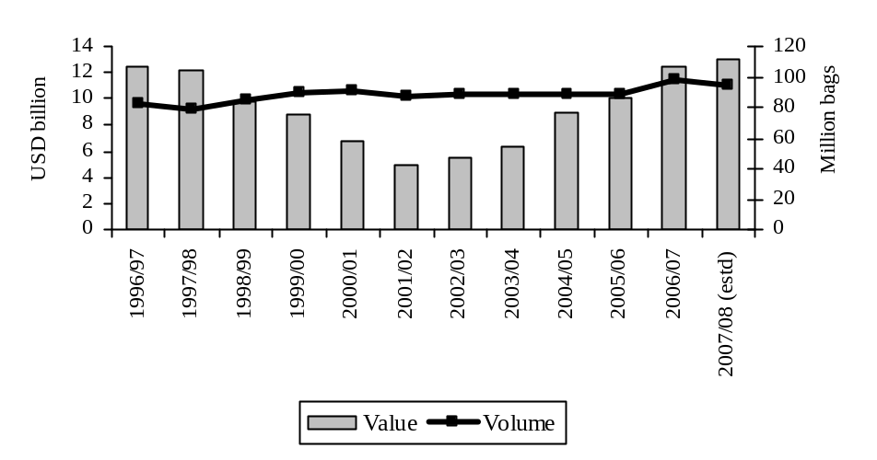
Source: ICO (2008)
Detailed exports by type of coffee and by selected countries and regions are shown in Table 5 below. Arabica and Robusta green coffee bean exports accounted for 92.5 per cent of total coffee exports in 2006/2007, with instant coffee accounting for most of the remainder.

Brazil is the largest coffee exporter, accounting for 26.25 per cent of the total coffee exports in the world. Whilst Brazil produces both natural Arabica and Robusta, exports are mainly natural Arabica because most of its Robusta production is for the domestic instant coffee industry (Roldán-Pérez 2007). Vietnam follows, with an 18.51 per cent share of global coffee exports, making it the world’s most important Robusta exporter. Vietnamese exports grew impressively from 11.52 million bags in 2002/2003 to 18.06 million bags in 2006/2007 (ICO 2009) (Table 5). Colombia is the third largest exporter, accounting for 10.85 per cent of world coffee exports in 2006/2007; the quantity of Colombian exports have remained stable over the last five years. These three countries represent 55.61 per cent of total world coffee exports. Indonesia is the fourth largest coffee exporter but its relevance has decreased in the last decade, and its Robusta exports only account for 3 per cent of total coffee exports (Table 5).

In 2006/07, exports of roasted coffee from producing countries accounted for the green bean equivalent (GBE) of only 182,927 bags, representing a relatively insignificant proportion of the overall trade in coffee at about 0.20 per cent of total coffee exports (ITC 2008). Exports of instant coffee accounted for almost 7.3 per cent of world coffee exports. They have been growing in recent years, from 5.67 million bags in GBE in 2002/2003 to 7.12 million bags in 2006/2007 (Table 5).

Brazil is the main instant coffee exporter, with Colombia being another important player among the Latin American countries. Recently Vietnam has started to export local instant coffee but at a preliminary stage. Indonesia also produces instant coffee but in smaller proportions than other countries. However, instant coffee exports from developing countries grew by 25.52 per cent between 2002/2003 and 2006/2007 (Table 5), although their overall market share is still small due to high competition with large, established companies in developed countries and high import tariffs (Roldán-Pérez 2007).

Table 5: Overview of world coffee exports by type, 2002/03-2006/07 (millions of bags)

Coffee year | 2002/03 | 2003/04 | 2004/05 | 2005/06 | 2006/07 | Per cent change 2002/03-2006/07 | Coffee exports as per cent of total exports 2006/2007
World | 88.24 | 88.71 | 89.75 | 87.87 | 97.59 | 10.60
Arabicas | 54.83 | 54.39 | 55.90 | 55.39 | 59.64 | 8.77 | 61.11
Brazil | 21.10 | 21.23 | 22.95 | 21.33 | 24.04 | 13.95 | 24.64
Colombia | 9.91 | 9.542 | 10.34 | 10.10 | 10.59 | 6.86 | 10.85
Other Latin America | 15.94 | 15.37 | 14.44 | 15.70 | 16.90 | 6.07 | 17.32
Africa | 5.31 | 5.232 | 5.453 | 5.16 | 5.54 | 4.37 | 5.68
Asia and the Pacific | 2.57 | 3.010 | 2.713 | 3.10 | 2.56 | -0.58 | 2.62
Robustas | 27.53 | 28.26 | 27.76 | 26.39 | 30.66 | 11.37 | 31.41
Brazil | 3.67 | 0.949 | 1.026 | 1.01 | 1.57 | -57.16 | 1.61
Other Latin America | 0.13 | 0.109 | 0.272 | 0.29 | 0.24 | 78.03 | 0.24
Vietnam | 11.52 | 14.46 | 13.95 | 13.08 | 18.07 | 56.77 | 18.51
Indonesia | 3.90 | 4.36 | 5.431 | 4.51 | 2.93 | -24.67 | 3.01
Other Asia and Pacific | 2.01 | 2.298 | 1.945 | 2.75 | 2.24 | 11.64 | 2.30
Cote d’Ivoire | 2.20 | 2.36 | 1.71 | 1.69 | 1.81 | -17.79 | 1.85
Uganda | 2.35 | 1.968 | 1.984 | 1.41 | 2.11 | -10.04 | 2.17
Other Africa | 1.75 | 1.762 | 1.440 | 1.66 | 1.69 | -3.71 | 1.73
Roasted Coffee | 0.21 | 0.11 | 0.11 | 0.25 | 0.18 | -14.49 | 0.19
Instant | 5.67 | 5.95 | 5.98 | 5.83 | 7.12 | 25.52 | 7.29
Brazil | 2.80 | 3.21 | 3.293 | 3.06 | 3.28 | 16.88 | 3.36
Other Latin America | 1.50 | 1.46 | 1.74 | 1.78 | 1.93 | 29.03 | 1.98
Africa | 0.42 | 0.25 | 0.251 | 0.40 | 0.89 | 111.93 | 0.91
Asia | 0.95 | 1.03 | 0.695 | 0.59 | 1.03 | 7.67 | 1.05
Share of global exports (per cent)
Arabicas | 62.14 | 61.31 | 62.78 | 63.04 | 61.10 | -1.67 | 62.61
Robustas | 31.20 | 31.86 | 30.57 | 30.04 | 31.41 | 0.67 | 32.18
Roasted | 0.24 | 0.13 | 0.12 | 0.29 | 0.20 | -16.67 | 0.20
Instant | 6.42 | 6.70 | 6.53 | 6.63 | 7.29 | 13.55 | 7.47
Source: ITC (2008)

Table 6 below shows the volume and value of world coffee exports under the four coffee groups classified by the ICO. In 2007/2008, Robusta exports were 33.11 million bags at USD 4.43 billion, Brazilian natural Arabica exports were 27.47 million bags at USD 4.47 billion, other mild Arabica exports were 22.6 million bags at USD 3.89 billion and, finally, Colombian mild Arabica exports were 12.71 million bags at USD 2.43 billion. Thus the largest group in volume is Robusta and the largest group in value is the Brazilian natural Arabica (Table 6).

Table 6: Volume and value of exports by group of coffee (millions of bags/ USD millions)

Crop year | 2004/05 | 2005/06 | 2006/07 | 2007/08 *
Colombian Milds
- Volume | 12.19 | 11.88 | 12.51 | 12.71
- Value | 1.72 | 1.80 | 2.02 | 2.43
Other Milds
- Volume | 19.32 | 20.49 | 21.37 | 22.06
- Value | 2.53 | 2.87 | 3.20 | 3.89
Brazilian Naturals
- Volume | 27.95 | 26.68 | 29.73 | 27.47
- Value | 3.04 | 3.29 | 4.02 | 4.47
Robusta
- Volume | 30.62 | 29.20 | 34.59 | 33.11
- Value | 1.72 | 2.12 | 3.24 | 4.43
Total
- Volume | 90.09 | 88.25 | 98.21 | 95.34
- Value | 9.01 | 10.08 | 12.48 | 15.22
Source: ICO (2009b)

2.2.6 World coffee consumption

According to the International Trade Centre (2008), global consumption in coffee year 2006/07 totalled 125.9 million bags. That constituted a 2.26 per cent growth on the previous year (89.85 million bags in 2005/2006) (ICO 2008) (Table 7 and Figure 4). In 2006/2007, importing countries’ consumption accounted for 73 per cent of global consumption (91.8 million bags) with an average annual growth since 2002/2003 of 8.72 per cent (Table 7 and Figure 5). Conversely, coffee consumption in producing countries for the same year accounted for 27 per cent of global demand (34.02 million bags) (Figure 4). In 2008, world coffee consumption is estimated to have reached 128 million bags, comprising 79 million bags of Arabica and 49 million bags of Robusta (ICO 2009).

Figure 4: World coffee consumption, 2002/03-2006/07 (millions of bags)

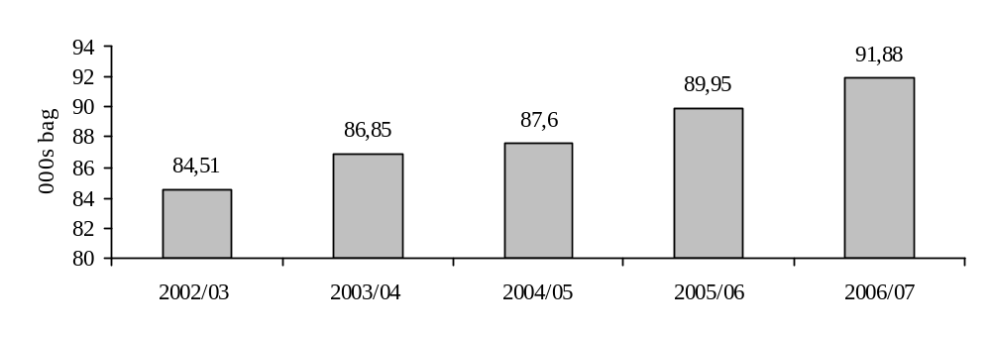Source: ITC (2008)

The US is the world’s largest consumer of coffee, accounting for 23 per cent of consumption among importing countries in 2006/2007 with 21.21 million bags. Germany is the second largest coffee consumer at 9.08 million bags, accounting for 10 per cent of consumption among importing countries. Japan, Italy and France are the third, fourth and fifth next largest coffee consumers among importing countries. The most impressive growth has probably been experienced by Japan, where consumption grew by 8 per cent between 2002/2003 and 2006/2007 (Table 7 and Figure 5).

Table 7: Consumption in importing countries/regions, 2002/03-2006/07 (millions of bags)

Consuming Countries/areas | 2002/03 | 2003/04 | 2004/05 | 2005/06 | 2006/07 | Per cent change 2002/2003-2006/2007 | Per cent total consumption 2006/2007
World | 84.51 | 86.85 | 87.60 | 89.85 | 91.88 | 8.72
North America | 22.20 | 23.48 | 23.43 | 24.43 | 24.74 | 11.45 | 26.93
United States | 20.05 | 20.73 | 20.63 | 21.33 | 21.21 | 5.75 | 23.08
Western Europe* | 41.41 | 41.30 | 41.43 | 42.21 | 42.86 | 3.50 | 46.65
France | 5.43 | 5.04 | 4.773 | 5.11 | 5.54 | 2.01 | 6.03
Germany | 9.45 | 9.14 | 9.183 | 8.92 | 9.08 | -3.87 | 9.88
Italy | 5.40 | 5.53 | 5.626 | 5.48 | 5.82 | 7.70 | 6.33
Eastern Europe* | 5.91 | 5.86 | 5.993 | 6.01 | 6.15 | 4.04 | 6.69
Asia and the Pacific | 10.77 | 11.67 | 12.13 | 12.70 | 12.77 | 18.55 | 13.89
Japan | 6.72 | 7.152 | 7.023 | 7.27 | 7.27 | 8.16 | 7.91
Others | 4.22 | 4.554 | 4.625 | 4.51 | 5.36 | 27.01 | 5.83
Source: ITC (2008)
Note: *Western Europe includes the enlarged EU. Eastern Europe excludes EU countries.

Figure 5: Coffee consumption in importing countries/regions, 2002/03-2006/07 (thousands of bags)

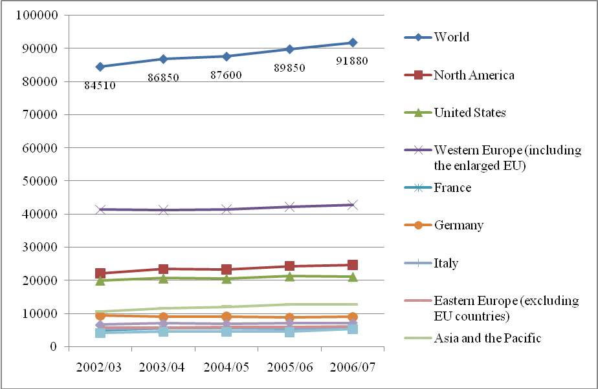
Source: ITC (2008)

Domestic consumption in producing countries was estimated by the ICO to be 34.23 million bags in 2007/2008 (Table 8). Of producing countries, Brazil is by far the largest consumer, with its 17.1 million bags accounting for almost 50 per cent of total consumption in coffee producing countries. Indeed, Brazil is the second largest coffee consumer in the world. There are two major explanations for the increase in domestic consumption in Brazil: first, an increase in disposable income in Brazil in recent years; second, Brazil has implemented a policy of using better quality coffee for its internal consumption. Countries like Colombia and Vietnam are trying to do the same, in order to boost their domestic consumption (Roldán-Pérez 2007, p. 36). Among producing countries Mexico was the second largest coffee consumer in 2007/2008 with 2.2 million bags, followed by Indonesia, Ethiopia, India and Colombia. Although Vietnam is the second largest producer of coffee in the world, its domestic consumption is still very small, at only 1 million bags in 2007/2008 (Table 8).

Table 8: Domestic consumption in coffee producing countries, 2007/08 (estimated)

 |  | Million bags
Africa |  | 3.282
 | Cote d'Ivoire | 317
 | Ethiopia | 1.833
Asia and the Pacific |  | 6.679
 | India | 1.430
 | Indonesia | 2.000
 | Philippines | 1.060
 | Vietnam | 1.000
Latin America |  | 24.271
 | Brazil | 17.100
 | Colombia | 1.400
 | Mexico | 2.200
 | Venezuela | 760
Total |  | 34.232

Source: ITC (2008) based on ICO data.
Note: Figures are rounded up to the nearest thousand.

Table 9 illustrates per-capita consumption in main importing countries from 2001 to 2005. European countries have the highest per capita coffee consumption in the world, with the Scandinavian countries being the highest. Finland is the world’s largest per capita consumer of coffee, consuming 12 kg of coffee per person in 2007, followed by Norway, Denmark, Sweden and Switzerland. The main European importing countries like Germany, France and Italy have lower consumption per person compared with the Scandinavian countries, as does the US (Table 9).

Table 9: Per capita coffee consumption in main importing countries (kg/person)

Country | Year
 | 2001 | 2002 | 2003 | 2004 | 2005 | 2006 | 2007
Finland | 10,8 | 11 | 11,3 | 11,7 | 12,6 | 11,8 | 12
Norway | 9,4 | 9,1 | 9,0 | 9,2 | 9,6 | 9,6 | 9,9
Denmark | 9,7 | 9,0 | 8,1 | 9,4 | 8,8 | 9 | 8,7
Sweden | 8,4 | 8,2 | 7,9 | 8,2 | 7,8 | 7,8 | 8,2
Switzerland | 7,2 | 6,3 | 7,3 | 5,9 | 8,7 | 8,2 | 7,9
Germany | 6,9 | 6,7 | 6,7 | 7,5 | 6,1 | 5,5 | 6,4
Canada | 4,9 | 4,4 | 4,1 | 5,2 | 5,2 | 5,7 | 6,5
France | 5,5 | 5,7 | 5,3 | 4,8 | 4,6 | 4,7 | 5,4
Spain | 4,2 | 4,1 | 3,9 | 3,8 | 4,0 | 4,0 | 4,5
United States | 4,0 | 4,0 | 4,1 | 4,2 | 4,1 | 4,0 | 4,2
Japan | 3,3 | 3,4 | 3,2 | 3,4 | 3,4 | 3,5 | 3,3
United Kingdom | 2,3 | 2,2 | 2,3 | 2,5 | 2,5 | 2,5 | 2,8
Poland | 3,5 | 3,4 | 3,5 | 3,6 | 3,6 | 3,4 | 2,4

Source: ICO (2008)
Per capita consumption in producing countries is still low compared to the importing countries. The largest per capita consumer among these countries is Costa Rica, with less than half of Finland’s consumption at 5.4 kg of coffee per person in 2005, followed by Brazil, the Dominican Republic and Colombia (Table 10).

Table 10: Per capita coffee consumption in main producing countries (kg)

Year | 2001 | 2002 | 2003 | 2004 | 2005
Brazil | 4.6 | 4.6 | 4.7 | 5.1 | 5.3
Costa Rica | 3.9 | 3.7 | 3.2 | 5.2 | 5.4
Dominican Republic | 2.3 | 2.4 | 2.4 | 2.6 | 2.5
Colombia | 2.0 | 1.9 | 1.9 | 1.9 | 1.9
Honduras | 2.0 | 1.8 | 1.8 | 2.0 | 1.9
Mexico | 0.8 | 0.9 | 0.9 | 0.9 | 0.8
Source: ICO (2004, 2005, 2006)

Coffee demand is also highly concentrated to a few destinations. According to the ICO, only 26 countries import significant quantities of coffee (180 thousand bags and above). High concentration also happens in other steps of the value chain of coffee, in the transformation and process of the bean. Studies have found that few roasters and retailers control a large proportion of their segments (Reina et al. 2007, p. 47). In 2001, only five traders controlled 48 per cent of business activity. Similarly, in 2006 only five roasters controlled 47 per cent of business activity. Nestlé roasted 12.5 million bags, Kraft 12 million, Sara Lee 8 million, Folger 4.8 million and Tchibo 4 million bags (Table 11).

Table 11: Concentration of MNCs in the international coffee industry, 2006

Coffee processing companies | Million bags
Nestlé | 12.5
Kraft | 12
Sara Lee | 8
Folger | 4.8
Tchibo | 4
Subtotal (47% of world market) | 41.3

Source: National Federation of Coffee Growers (NFC 2006), based on Volcafé data.

Nowadays, retailers and roasters have gained high negotiating power, with their deepening knowledge of their needs and of different consumer preferences and the development of their own brands. For instance, in the roasted coffee market, distributed by supermarkets in the US, Kraft Foods and Procter and Gamble had more than 75 per cent of the sales market in 2002 (Reina et al. 2007). In the same year, companies such as Kraft Jacobs Suchard and Tchibo/Eduscho had 56 per cent of the market in Germany, while Ueshima Coffee and Key Coffee had 43 per cent of the Japanese market (Reina et al. 2007, p. 48).

2.2.7 The International Coffee Organisation and coffee prices

Coffee is an important commodity for many economies; it has experienced periods of oversupply and low prices and other periods of short supply and high prices, where the former have been longer than the latter. After price fluctuations in the 1950s and the 1960s, an intergovernmental initiative came into effect to stop the fall in prices and avoid negative political and economic consequences for developing country producers (Roldán-Pérez 2007). For this purpose, the International Coffee Organisation was initiated in London in 1963 with the support of the United Nations, due to the high economic significance coffee had for developing countries.

At its inception, the main function of the ICO was to establish coffee export quotas and the level of coffee market prices. In July 1989, however, the system collapsed under the pressure of competing demands by exporters for market share. The consequences were the suspension of coffee export quotas and the start of negotiations on a new International Coffee Agreement (Roldán-Pérez 2007). The price trend can be observed in Figure 6 below.

Figure 6: ICO composite price (US cents per pound)

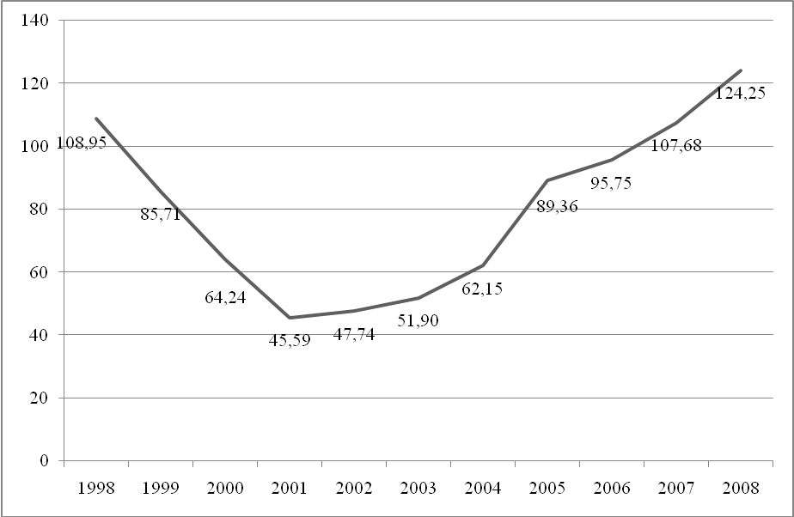
Source: ICO (2009)

The ICO is the main intergovernmental organisation for coffee that aims to deal with the challenges that the coffee industry faces through international cooperation. It contributes to the coffee economy and to improving the standard of living in producing countries dependent on coffee (ICO 2009).

The ICO established the indicator price system to provide a trustworthy and consistent procedure for keeping record of prices for different types of coffee, as well as a composite price which would reflect the weighted average of daily movements in the price of coffee (ITC 2008). The composite indicator price is obtained by taking a weighted average of the indicator prices for each separate group, i.e. the relative share of each group in overall international trade. The weight by group is: Colombian milds, 14 per cent; other milds, 20 per cent; Brazilian naturals, 31 per cent; and Robustas, 35 per cent (ICO, 2008). The weight composition is reviewed every two years.
The ICO indicator price system is based on the four separate price groups. According to the price group, prices are determined by the US and German markets and, in the case of the Robusta price group, by the US and French markets; a daily weighted average is also calculated for each group (Table 12).

Table 12: ICO indicators price, annual average, 2001-2008 (US cents per pound)

 |  | Colombian Mild Arabicas |  |  | Other Mild Arabicas |  |  | Brazilian Natural Arabicas |  |  | Robustas
Annual/  monthly  averages | ICO  Composite  Price | Market |  | Daily  weighted  average |  |  | Daily  weighted  average | Market |  | Daily  weighted  average | Market |  | Daily  Weighted  Average
Annual/  monthly  averages | ICO  Composite  Price | New  York | Germany | Daily  weighted  average | New  York | Germany | Daily  weighted  average | New  York | Germany | Daily  weighted  average | New  York | France | Daily  Weighted  Average
2001 | 45.59 | 72.22 | 68.24 | 72.05 | 61.94 | 63.14 | 62.28 | 50.52 | 52.42 | 50.70 | 27.30 | 27.49 | 27.54
2002 | 47.74 | 65.26 | 64.78 | 64.90 | 60.43 | 62.31 | 61.52 | 45.09 | 45.92 | 45.23 | 30.83 | 29.76 | 30.01
2003 | 51.90 | 67.31 | 64.34 | 65.33 | 64.08 | 64.30 | 64.20 | 50.82 | 50.16 | 50.31 | 38.39 | 36.50 | 36.95
2004 | 62.15 | 84.15 | 79.49 | 81.44 | 80.15 | 80.64 | 80.47 | 68.18 | 69.11 | 68.97 | 37.28 | 35.65 | 35.99
2005 | 89.36 | 117.02 | 114.67 | 115.73 | 114.30 | 115.22 | 114.86 | 101.36 | 102.49 | 102.29 | 53.37 | 49.87 | 50.55
2006 | 95.75 | 118.36 | 115.70 | 116.80 | 113.95 | 114.80 | 114.40 | 102.89 | 104.19 | 103.92 | 70.28 | 66.98 | 67.55
2007 | 107.68 | 126.74 | 124.70 | 125.57 | 123.20 | 123.81 | 123.55 | 110.72 | 112.06 | 111.79 | 88.29 | 86.29 | 86.60
2008 | 124.25 | 145.85 | 143.12 | 144.32 | 138.32 | 140.86 | 139.78 | 122.51 | 127.86 | 126.59 | 106.31 | 105.03 | 105.28
2009
January | 108.39 | 148.88 | 137.62 | 142.32 | 128.03 | 128.93 | 128.30 | 101.43 | 111.65 | 109.18 | 85.77 | 82.11 | 82.74
February | 107.60 | 149.58 | 140.74 | 144.55 | 128.63 | 130.13 | 129.48 | 100.45 | 109.87 | 107.69 | 81.66 | 79.90 | 80.22
Source: ICO (2009)

World coffee prices fluctuate daily, determined by supply and demand (Roldán-Pérez 2007). After the Brazilian drought in 1976, the ICO kept prices high until its collapse in 1989, when international prices started to fall significantly. Prices were at a high level in the mid-1990s due to a loss of Brazilian production of 13 million bags of coffee (idem). However, world production had increased by 1999, mainly due to the improvement in Brazilian policies to boost domestic consumption and the growth of Vietnam as a Robusta producer. Coffee prices sunk to their lowest level in 30 years between 2000 and 2001, when global oversupply caused them to drop below cost, causing serious damage to domestic producer economies (idem). Since 2005, world coffee prices have been recovering from the 1999 level, reaching a price of 107.6 US cents per pound in February 2009 (Table 12 above), resulting in some improvement in profits for traders, roasters and producers themselves.

2.2.8 Mapping the global value chain of coffee

The coffee industry has, following recent trends in the primary products market, become more differentiated (Fitter and Kaplinsky 2001). For example, the Fair trade share of the coffee industry has been growing: in 2007, imports of Fair trade coffee increased by 19 per cent, whereas coffee imports increased by only 2 per cent (FLO 2008; ICO 2008).

Whilst the coffee trade has been liberalised, the industry has developed several self-regulatory systems. These governance systems mainly improve the reputation of its members, which are the coffee-growing farmers, and facilitate the relationship between roasters or traders and coffee growers. National coffee institutes in coffee producing countries have had a particular impact on improved coordination along the links of the coffee value chain (Muradian and Pelupessy 2005).
According to Kaplinsky (2006), the coffee value chain can be upgraded through product development and positional consumption. Producers have focused mainly on productivity improvement, whereas roasters and retailers have emphasised product innovation (idem). Regarding functional upgrading, growers have been blocked from moving up the value chain to the processing stages by tariff escalation policies (Talbot 1997). Regarding other value chains, many producers have been forced out of coffee production because the variable costs are not being covered (idem).

As drawn by Fitter and Kaplinsky (2001), a general value chain for the coffee industry can be described as follows:

- First, farmers pick and dry- or wet-process the coffee cherries. They receive a farm-gate price for the coffee beans;
- The coffee cherries are continuously processed, with a factory-gate price paid for both the dry- and wet-processed coffee cherries;
- The beans are passed to an intermediary for exportation, at the ‘free on board’ (FOB) price;
- The beans are sent to the importing countries, where they arrive at the ‘cost, insurance and freight’ (CIF) price;
- They are then sold at wholesale prices;
- The beans are then roasted and sold at factory-gate prices;
- Finally, retailers sell the beans at retail prices to the public for domestic consumption, or for out-of-home consumption by restaurants, caterers and coffee bars (Fitter and Kaplinsky 2001).

The following graphic, based on Keane (2008), illustrates the value added at each stage of the coffee chain.

Figure 7: Value added created at each stage of the coffee GVC
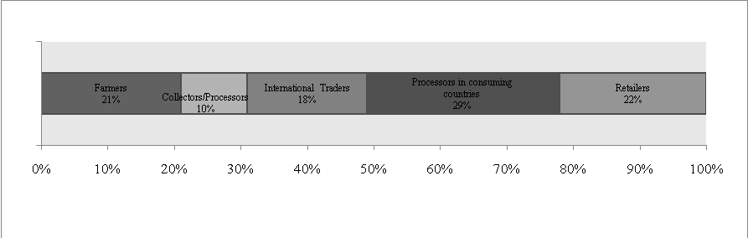Source: Kaplinsky and Fitter (2001)

The following graphic represents the global value chain of coffee.

Figure 8: The global value chain of coffee
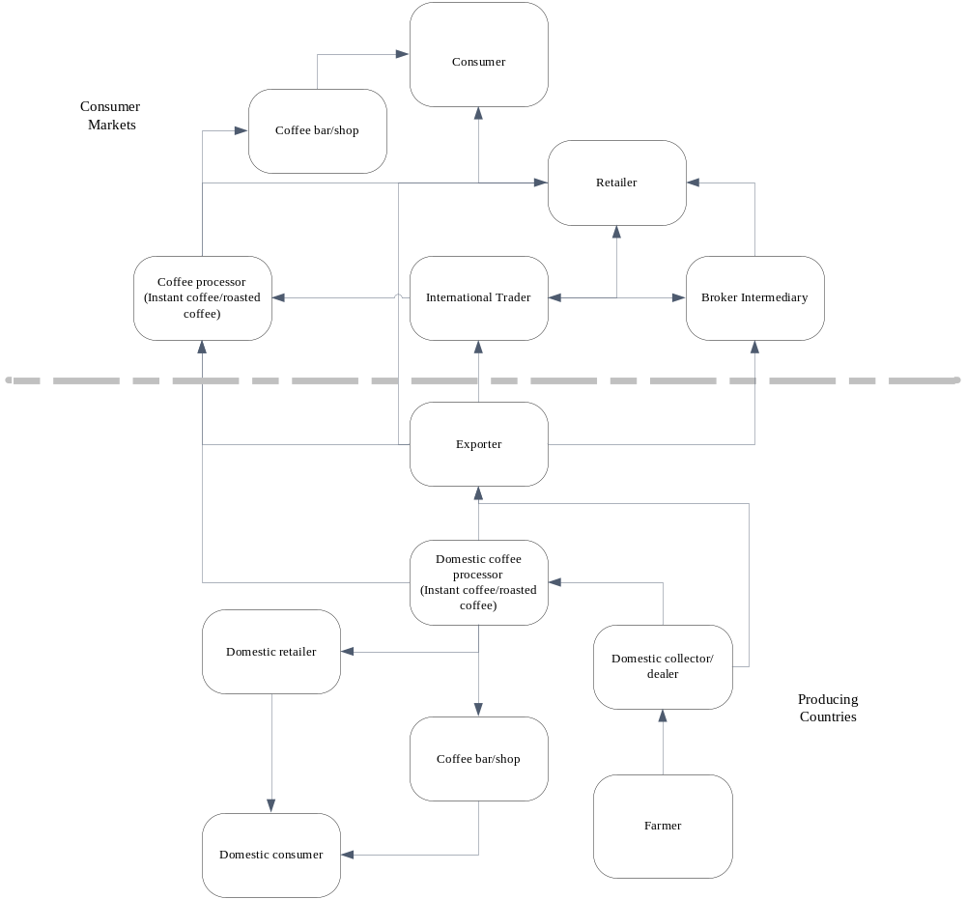
Source: authors.

3 Analysis of Colombia and Vietnam’s participation in the coffee value chain

3.1 Vietnam’s participation in the GVC of coffee

3.1.1 Background

Coffee was introduced to Vietnam in 1857. It was first planted in the precincts of churches in Ha Nam, Quang Binh and Kon Tum provinces. At the beginning of the 20th century, coffee bushes were planted on quite a large scale by French plantation owners at Phu Quy – Nghe An and later at Dak Lak and Lam Dong.

In the 1960s and 1970s coffee was planted in some state-run plantations in the northern provinces of Vietnam, but did not become established because of insect damage to the Arabica variety and unsuitable natural conditions for the Robusta variety. In 1975, when the nation was united, Vietnam had more than 13,000 hectares (ha) planted with coffee, producing 6,000 tons in total (Long 2007).

Thanks to funding from agreements between the Vietnamese government and countries such as the former Soviet Union, the German Democratic Republic, Hungary, Slovenia and Poland, coffee has been heavily developed in the Central Highlands since 1975. 500,000 ha have now been planted with an output of about 1 million tons (Nhan 2008).

3.1.1.1 Natural conditions

The coffee-growing area in Vietnam increased rapidly from 19,800 ha in 1982 to 529,000 ha in 1999 (Nhan 2008). However, since 1999, the area has fluctuated at around 500,000 ha (Figure 9 below).

Figure 9: Vietnam’s coffee-growing area (thousands of ha)
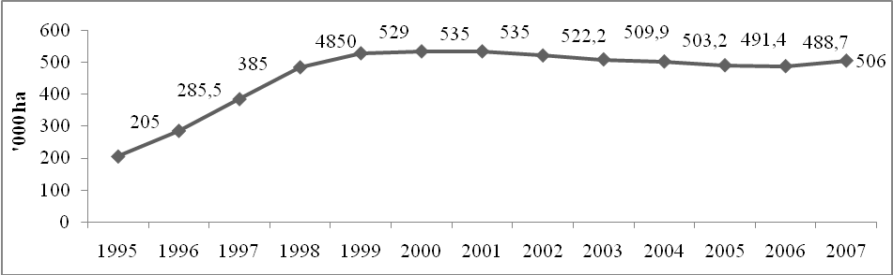Source: VICOFA in Nhan, 2008

According to Long (2007), Vietnamese coffee includes Robusta (accounting for around 90 per cent), Arabica (around 10 per cent) and Exelsa (less than 1 per cent).

Robusta is popular in southern provinces such as Lam Dong, Gia Lai, Dong Nai, Kon Tum and Dak Lak. Robusta usually grows in tropical areas and is best suited to altitudes under 1,000m, temperatures from 24°C to 29°C, rainfall above 1000mm, and requires much sunlight. Robusta has a high caffeine content (2-4 per cent), so the flavour is not as pure as Arabica. Robusta, however, grows strongly and is more disease resistant. These characteristics suit the natural conditions in the southern provinces of Vietnam. Robusta grown there produces record yields and a more delicious flavour, and is the favourite of many countries in the world. However, the quality of the Robusta produced is uneven because of processing technology, drying equipment and post-harvest technological problems. These cause the coffee beans to have a high humidity level, and not meet the required standard of colour, quality and so on. This is the reason that Vietnam’s coffee price is lower than the world price.

Arabica is mainly planted in the mountainous areas of northern Vietnam. The 20,000 ha of Arabica are mainly in Tuyen Quang, Bac Giang, Thai Nguyen, Vinh Phuc, Lai Chau, Hoa Binh, Lang Son, Yen Bai and some areas in Quang Tri and Lam Dong, though on a smaller scale. Arabica is usually planted at attitudes of 1,000m to 1,500m with temperatures from 16°C to 25°C and rainfall above 1,000mm. Arabica does not need as much sunlight as Robusta. This kind of coffee, however, has a lower caffeine content (only 1-2 per cent) and is sensitive to some diseases such as rust, dry branch, dry fruit and pink disease. These characteristics make Arabica suitable for growing in provinces in the centre and north of Vietnam. Arabica coffee is more difficult to develop in Vietnam than Robusta because of unsuitable altitudes. Some areas specialising in coffee cultivation, such as Buon Ma Thuot Dak Lak and Bao Loc Lam Dong, are between 500m and 1,000m in altitude. For this reason, although the price of Arabica is twice that of Robusta, it is not planted on a large scale in Vietnam.

All coffee in Vietnam is harvested between October and January; therefore the consumption year is counted as the period from the start of October to the end of September in the following year.

3.1.1.2 Infrastructure

According to the Vietnamese General Statistics Office (GSO 2008), Vietnam’s coffee industry supports about 300,000 households with more than 600,000 workers, rising to 700,000 or 800,000 in the harvest season. This number accounts for 1.83 per cent of the total Vietnamese labour force and 2.93 per cent of its total agricultural labour force. Plantations and state-owned companies own only 10-15 per cent of the total 500,000 ha of coffee; the rest belongs to farm owners. The farms are usually from 2 ha to 5 ha in size.

In term of processing capacity, Vietnam has nearly 100 processing plants, with capacities ranging from 5,000 to 60,000 tons of coffee beans, producing a total of about 1 million tons every year. Most equipment is domestically produced with some being imported (e.g. wet-process lines from Brazil, colour classification machines from Japan). The level of technology employed is generally not sufficient to produce a high quality product, especially not for export. Low input quality is also a factor, with only 20 per cent meeting requirements.

In term of the production of ground roasted coffee and instant coffee, Vietnam has about 16 corporations and more than 10,000 smallholdings which specialise in roasting and grinding coffee. One of them is the state owned company Vinacafe; the others are joint stock and private companies with 50 process lines producing instant coffee with a total output of 10,000 tons per year.

The implementation of quality management systems and advanced food safety hygiene systems meeting international standards, such as those set under the International Organisation for Standardisation (ISO) and the Hazard Analysis and Critical Control Points (HACCP), is limited. In 2006, Vietnam issued a quality standard for coffee, TCVN 4193:2005, but it is not compulsory and only 10 per cent of coffee exporters adhere to it, accounting for around 1-2 per cent of exports.

3.1.1.3 Policy and legal frameworks

Vietnam is looking to promote coffee to non-traditional and domestic markets. The Vietnam Coffee and Cocoa Association (VICOFA) has reportedly signed a cooperative agreement for annual coffee exports of around 10,000 tons to China. Vietnam hopes that its huge neighbour will become a market for its coffee.

Vietnam also sees importance in promoting coffee in the domestic market of more than 80 million people. Vietnam will work on promotion programmes to increase coffee consumption in the domestic market to a million bags, from the current level of a half-million bags, in the near future. Coffee festivals were held in Buon Ma Thuot city in 2007 and 2008, attracting business people and consumers to visit and find out about coffee culture. The Ministry of Agriculture and Rural Development has approved a plan to increase the coffee sector’s competitive capacity through 2015 and has a vision for 2020 with investment reaching nearly 33,000 billion Vietnamese Dong (VND) – around USD 1.88 billion. The plan aims to ensure that all Vietnamese coffee products are produced in line with international quality standards and traded on an equal footing in the international market. The state budget funds a major part of the total VND 33,000 billion that will be used to implement transport projects in the Central Highlands provinces and coffee growing areas in the central and north-western regions. Investment will be poured into the building of reservoirs and canal systems to ensure that 75 per cent and 100 per cent of coffee growing areas will be irrigated by 2015 and by 2020, respectively.

In addition, official development assistance funding worth VND 13,075 billion (around USD 747 million) will be spent on intensive farming for 200,000 ha of coffee in some Central Highlands provinces, including Dak Lak, Lam Dong, Gia Lai and Dak Nong, and 6,000 ha of tea and coffee in Lam Dong, Quang Tri, Thua Thien-Hue and Son La. Approximately VND 18,585 billion (around USD 1.06 billion) from businesses and individuals will be used to purchase machines and processing equipment (Vietnam Trade Office in the USA 2008).

Vietnam has also put coffee trading floors into operation in the Central Highlands and will open another in Ho Chi Minh City. These will apply modern transaction methods, such as deadline transactions, to prevent market fluctuation risks and put Vietnamese coffee on international trading floors.

To improve export coffee quality, the government and coffee organisations are recommending that coffee exporters apply the new coffee standards that were introduced in early 2002 (see Report VM-3012). However, very few coffee exporters have used the new standards, as they do not receive much encouragement to do so, or higher prices from importers as a consequence. According to the Vietnamese Ministry of Trade, strict enforcement of the new standards will be necessary to improve coffee quality for export. International buyers seem to disagree with the standards and/or like buying poor quality coffee at cheap prices.

Vietnam’s Coffee and Cocoa Association also wants coffee buyers to participate in the coffee quality improvement programme. It advocates coffee importers purchasing coffee at the lower moisture rate of 12.5 per cent instead of the current rate of 13 per cent, and reducing the foreign market percentage for export coffee to 1 per cent from the current level of 5 per cent. Again, it seems that international buyers are reluctant to actually demand better quality coffee through higher prices.

In 2003, Vietnam and Indonesia (two leading Southeast Asian Robusta coffee powerhouses) signed a memorandum of understanding to retain 20 per cent of their production if export prices are too low. However, many in Vietnam see that idea as unfeasible (and expensive). According to VICOFA, the programme would cost Vietnam at least VND 1,400 billion (around USD 80 million) to keep 140 tons of Robusta off the market. Moreover, assuming Vietnam and Indonesia did retain large stocks, importers could easily buy coffee from other countries because Vietnamese and Indonesian Robusta coffee exports only amount to about 35 per cent of the global Robusta coffee trade.

3.1.2 Vietnam’s position in the global coffee market

Vietnam’s exporting situation over recent years is notable for the rapid growth in export output and turnover. Coffee is currently the leading product, in export turnover, of the agriculture and forestry product sector.

Table 13: Export output and turnover of Vietnamese coffee

Year | Output  (millions of tons) | Changes compared to the previous year (per cent) | Turnover  (USD thousands) | Changes compared to the previous year (per cent) | Per cent of total export
1995 | 212 | 0 | 560 | 0 | 10.28
1996 | 233 | 10 | 423 | -24 | 5.83
1997 | 392 | 68 | 491 | 16 | 5.35
1998 | 382 | -3 | 594 | 21 | 6.35
1999 | 482 | 26 | 585 | -2 | 5.07
2000 | 734 | 52 | 501 | -14 | 3.50
2001 | 931 | 27 | 391 | -22 | 2.60
2002 | 722 | -22 | 322 | -18 | 1.93
2003 | 691 | -4 | 428 | 33 | 2.12
2004 | 975 | 41 | 641 | 50 | 2.42
2005 | 885 | -9 | 735 | 15 | 2.28
2006 | 897 | 1 | 1,101 | 50 | 2.76
2007 | 1,209 | 35 | 1,878 | 71 | 3.87
2008 | 1,132 | -2 | 2,116 | 12.5 | 3.36
Source: Authors, based on annual reports by Vietnam’s Ministry of Trade, 1996-2008.

3.1.2.1 Export output

Export coffee output reached 931 million tons in 2001 but decreased rapidly to 722 million tons in the following year. Output in the following years increased and reached a peak in 2007. The average growth rate of coffee exports in the period 1995-2007 was 19.43 per cent.

3.1.2.2 Export turnover

Vietnam’s turnover from coffee has increased continuously. Vietnam exported 212 million tons of coffee in 1995 and this figure increased to 1,209 million tons in 2007, with a turnover of USD 1.87 million (a record in both quantity and price). The average growth rate of export coffee turnover was 10.94 per cent between 1995 and 2007. Vietnam had 179 corporations exporting coffee in 2007, an increase of 26 corporations on 2006 (Nhan 2008).

Export turnover increased more slowly than output growth because of fluctuations in export prices. In the period 2001 to 2005, in particular, export turnover did not increase much and even decreased, despite a sudden growth in export output. In 2001, for example, export output reached 931 million tons (an increase of 26.8 per cent on the previous year) but export turnover fell to USD 391 million, equivalent to just 78 per cent of the previous year’s turnover (Figure 10 below).

Figure 10: Vietnam’s coffee exports by value and by volume, 1995-2007 (USD millions/ thousands of tons)
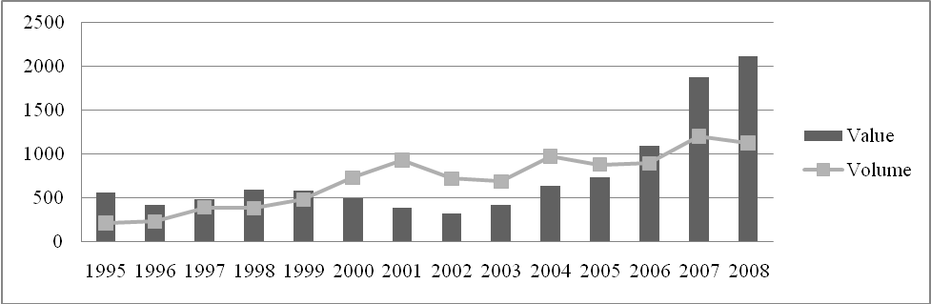 Source: Authors, based on annual reports by Vietnam’s Ministry of Trade, 1996-2008.

Although supply resources for exporting were limited in 2008, there was a good price so it was estimated that the export turnover of Vietnamese coffee would increase by about 12 per cent in comparison with 2007, with a total value of more than USD 2 trillion. According to Vietnam’s Agriculture and Development Ministry, the output total in 2007-2008 is estimated to be 17.4 million bags, a fall of more than 17 per cent compared to 2006-2007. Vietnam has become the second largest coffee exporting country in the world after Brazil.

3.1.2.3 Export product structure

According to Huyen (2008), 95 per cent of Vietnam’s coffee exports are green coffee beans, 1-2 per cent is roasted ground coffee and 3-4 per cent is instant coffee. The reasons for this are weak processing capacity and a lack of brands.

Robusta accounts for nearly 95 per cent of Vietnam’s total output and Vietnam’s output accounts for 41.3 per cent of Robusta produced in the world. The price of Arabica is much higher than Robusta, but it accounts for only 5 per cent of Vietnam’s exports.

The quantity of processed coffee, such as roasted coffee and instant coffee, which is exported, is too small. Roasted coffee and instant coffee exports accounted for only 0.43 per cent of Vietnam’s total turnover from coffee in 2003, despite its high added value and profit level. Instant coffee’s added value is 3.41 times that of green coffee beans, whilst the export value of roasted coffee is 4.38 times that of green coffee beans (Huyen 2008). Whilst Vietnam’s processing ratio is too low, it is difficult to increase the quantity of processed coffee exported because Vietnam does not have a large market and is not strong enough to compete with famous coffee brands.
According to VICOFA (2008), there are around 150 exporters in Vietnam, concentrated in Daklak and Ho Chi Minh cities. Exporters include subsidiaries of the Vietnam Coffee Corporation (Vinacafe) and Intimex Import-Export Corporation (Intimex). The largest exporter is Tay Nguyen Coffee investment and import-export company (Vinacafe Tay Nguyen), a subsidiary of Vinacafe in Dak Lak, with around 20 per cent of the total coffee exports of Vietnam (Huyen 2008).

3.1.2.4 Export prices

The fluctuations in the average export price of Vietnamese coffee are shown in Figure 11 below.

Figure 11: Export price of Vietnamese coffee, 1995-2007 (USD per ton)

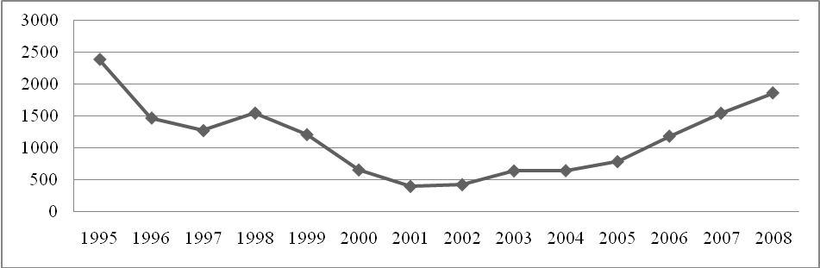Source: Nhan, 2008

The period from 1995 to 2001 was a period of depression for Vietnamese coffee, with a price reduction of 7.49 per cent per year, from USD 2,393 per ton in 1995 to USD 400 per ton in 2001. Low prices were the reason that coffee output in 2001 was high but export turnover was low.

Luong Xuan Quy and Le Dinh Thang have explained the fall of Vietnamese export coffee prices with reference to a rapid increase in world output followed by a fall in world prices (NEU 2006). At the beginning of the 1990s, Vietnam’s coffee output was not affected by the world price because Vietnam played only a small role in the world coffee market. Since the mid-1990s, however, Vietnam has become a big coffee exporting country. The world price increased suddenly from 1994-1996, which resulted in huge profits for Vietnamese farmers and encouraged them to increase coffee production. In 2001 coffee output increased, exceeding the predictions of the international specialists and coffee trading companies. It led to an excess of supply over demand, which pushed the coffee price down.

The export price gradually rose to USD 1,548 per ton in 2001-2007, four times that of 2001. However, it was not as high as the price in the golden age of coffee (1995). The average export price in 2007 increased by 25.12 per cent on the previous year, by 88.37 per cent compared to 2005, and by 265 per cent compared to 2001 prices. In December 2007, the average export price of Vietnamese coffee was USD 1,730 per ton, an increase of 21.57 per cent compared to 2006, and higher than the average export price in 2007 (USD 1,553 per ton).

The main reason that Vietnam’s coffee export turnover in 2007 was its highest ever is that the world price in general, and Vietnam’s export coffee price in particular, increased sharply. The average price of Vietnamese Robusta in 2007 was USD 1,605 per ton (compared to USD 1,260 per ton in 2006) and the world price was USD 1,718 per ton (compared to USD 1,335 per ton in 2006).

The export price of Vietnamese coffee broke its previous record in March 2008. The buying price of Robusta beans in Tay Nguyen reached USD 2,400 per ton, the highest price for 14 years. The reason for this was that countries in the southern hemisphere had a poor coffee crop. Brazil’s production fell by 23 per cent and Indonesia’s by 19 per cent, while the demand in coffee producing countries increased. In addition, many investment funds and coffee roasters bought reserves because they were concerned by the lack of coffee. Vietnam, therefore, had a chance to capture the world market. But Vietnam’s coffee price suddenly dipped by USD 190 per ton in the session of 9 March 2008. Having increased continuously for many days, many people failed to deal with the market signals, and because the price fell so rapidly Vietnamese farmers rushed to sell coffee, which made the market fall further. According to the Coffee Association, this movement was rooted in a fall in the London market. In addition, corporations sold a huge amount of coffee when prices were high, leading to a reduction in coffee prices. In general, export and domestic prices follow international market fluctuations. The gap between Vietnamese export prices and international prices is narrowing, but slowly. In fact, Vietnam’s export price is lower than that of other exporting countries by about USD 50-70 per ton. The principle reason is that Vietnam exports mainly Robusta, which has a lower export value than Arabica. Besides, the quality of Vietnamese coffee is not high and farmers often pluck all the coffee berries from the branches when harvesting, so that green berries are present.

3.1.2.5 Export markets

In terms of market structure, Vietnam has exported to 74 countries and territories, among them the ten leading importing countries in the EU and US. They have been Vietnam’s main markets from 1999 to 2007 (Nhan 2008).

Two big markets in Asia, Japan and Korea, are also important customers for Vietnam. The permanent markets among Southeast Asian nations are the Philippines and Malaysia, and recently Indonesia. Other countries, such as Poland, Russia and China, also buy coffee from Vietnam.

Vietnam also has some new customers in Latin America, such as Ecuador, Mexico, Chile, Paraguay and Nicaragua. It is noteworthy that Brazil – the leading coffee producing country in the world – intends to buy Vietnamese coffee to increase domestic consumption and establish a cooperative relationship with Vietnam. This market expansion may imply Vietnam’s comparative advantage in Robusta coffee (Figure 12 below).

Figure 12: Export markets for Vietnamese coffee
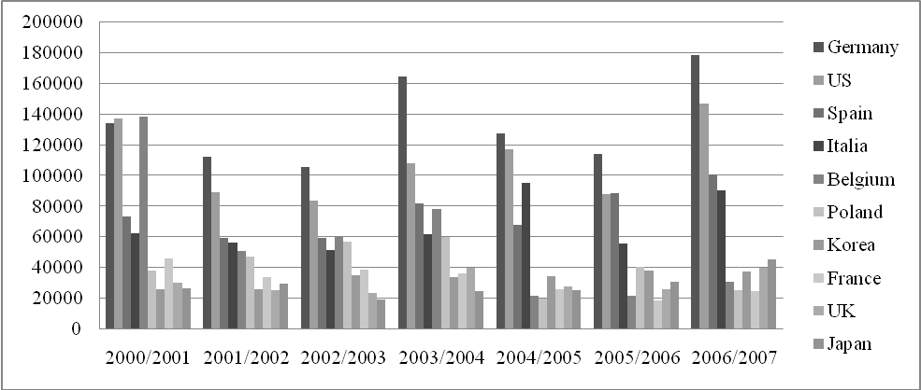Source: Nham, 2008

In 2007, European countries continued to be the primary importers of Vietnam’s coffee, accounting for more than 40 per cent of the total (mainly Germany, Spain, Italy, Poland and Belgium), followed by the US (over 9 per cent) and Asia (over 7.5 per cent).

In general, Germany and the US have lately been Vietnam’s largest customers. This is in contrast to 1992-1993, when Vietnam’s export markets were mainly Singapore, Hong Kong and Japan. This proves that the reputation of Vietnam’s coffee is improving.

Figure 13: Vietnam’s participation in the GVC of coffee
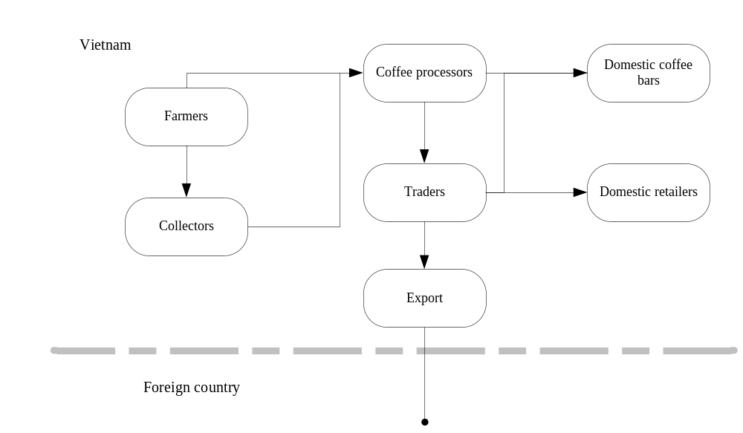Source: Authors

There are no statistics on Vietnam’s domestic coffee consumption. Interviews with experts indicate that it accounts for an estimated 5 per cent of total production. However, domestic consumption has significantly increased in recent years, reaching about 60,000 tons in 2005 compared with less than 40,000 tons three years ago. However, Vietnam’s domestic consumption per capita of around 0.5kg per year is much lower than the average for producing countries, which is 3kg (Vu 2008). Domestic coffee consumption is concentrated in Vietnam’s major cities. According to a survey by the Institute of Agriculture and Rural Development Strategy and Policy in March 2006, residents of Hanoi consume 0.752kg each year, while the figure in Ho Chi Minh city is 1.65kg, much higher than average. There is also a difference in consumption customs. In Ho Chi Minh City, 47 per cent drink coffee at coffee bars, while in Vietnam as a whole that figure is only 36 per cent (Huyen 2008). This number reflects the potential of Vietnam’s domestic coffee market, especially in the northern provinces (IPSARD 2006).

Most of Vietnam’s coffee exports are coffee beans and roasted ground coffee. There are few exporters of instant coffee. This is the reason that Vietnam occupies only a small proportion of the GVC of instant coffee. A 300g Nescafe box analysed in the UK market was found to have only 2 per cent of its contents sourced from Vietnam (Anh 2008).

3.1.3 Actors

The main players in Vietnam’s coffee value chain are described below.

3.1.3.1 Farmers

Farmers play the most important role in the value chain because they take part in the producing phase, the first phase in the chain.

There are three kinds of coffee farms: farms given land property rights by the state, farms which have received contracts from state-run farms, and farms cultivating their own land and forest land by themselves, without property rights.

Farms with land property rights are small in scale (around 2-5 ha each) but they account for the largest share of coffee-planting farms. Their main workforce consists of their family members; their capital is borrowed from banks and other resources. Coffee is the main income resource of households with good, flat land, stable water resources and access to transportation systems. But in less advantaged areas, agricultural production is more complicated and investment in intensive coffee cultivation is at a lower level.

Farms planting coffee based on contracts with state-run plantations and companies account for 10-15 per cent of coffee-planting households. These households have some rights and benefits but they also have certain responsibilities. They are supplied with fertiliser and irrigation. Some of them earn a monthly salary but they use their own labour and must sometimes invest more capital in fertiliser and other inputs besides those supplied to them (Huyen 2008).

The last group consists of households cultivating unused and forestland. Most of these households are quite rich and produce coffee on a large scale. They account for more than half of all coffee farms in Vietnam and use an average of 4.32 ha for planting coffee. The high-income households often sell dry coffee.

Methods of planting and taking care of coffee vary but have the same basic characteristics: using seeds and not paying attention to covering trees. In addition, they invest heavily in the farm and use fertiliser and irrigation to ensure high production in years with high prices. However, when prices fall farmers no longer want to invest in their farms, which makes them decline quickly and have a low economic impact. When harvesting, Vietnamese farmers often pluck all the berries on each branch, and do not distinguish between ripe berries and green ones in order to have a higher productivity.

Harvested coffee is processed in three ways. The first is green coffee: coffee berries harvested from bushes. The second is dry coffee: harvested coffee is dried using a simple method. And the last method is rush coffee: coffee is roughly processed by the dry-processing method. The dry-processing method means drying coffee berries by sunlight or by machines (some households buy drying machines), then rubbing them, throwing the skin away and keeping the beans only (hulling). Most households carry out all stages by themselves. Only a few households can afford to buy machines for post-harvest processing. Almost all households dry coffee by sunlight and then hire machines to process ‘rush’ coffee, rather than keeping it as green coffee. This method is cheap and easy. About 4.5 tons of coffee cherries are processed to make 1 ton of rush coffee.

Only a small quantity of coffee is sold green after harvest. The majority is sold as rush coffee to agents. The reason for this is that rush coffee has the best price, and processing it is quite simple. According to research by the Information Centre for Agriculture and Rural Development, households only sell green coffee when they are in need of money or when they cannot dry coffee because of rain. All households that sell green coffee do so to middlemen. A small amount of dry coffee is also sold to middlemen or agents. Few farmers sell coffee directly to processing or exporting companies, except for some companies that place orders to buy green coffee directly from households.

3.1.3.2 Middlemen

The role of middlemen and agents is to transport coffee from farmers to processing or exporting companies. Agents and middlemen buy about 90 per cent of coffee output. There are many agents and middlemen, so the price does not fluctuate much for each grade of coffee. However, prices for the different grades vary, from VND 50 to VND 100 per kg.

Agents and middlemen have two methods for buying coffee, either by collecting coffee beans at their own places or by using their own means of transportation, such as trucks, to buy coffee at farmers’ houses and transport directly to coffee processing plants.

These agents can be private companies or the subsidiaries (at province, commune or village level) of processing or exporting manufacturers. Staff of these agents are paid a salary by manufacturers.

This network is supported by coffee-collectors who are often the neighbours of agents. They have little money so they only collect from 5 to 200kg of coffee per day, and then resell it to agents; their profit is the difference between the prices. Most coffee-collectors buy green coffee and come directly to farms to buy it.

Coffee-collectors often have no other activities, but collecting-agents are different. After buying coffee, agents often carry out some rough processing activities to remove impurities (in the case of rush coffee already processed by households) or dry grind and polish (dry coffee) to make rush coffee, which is sold to processing or exporting companies. Their main profits come from rough processing activities and collecting (Huyen 2008).

3.1.3.3 Processing or exporting companies

Processing or exporting companies often buy coffee through their own agents or sign a contract with private collecting agents and often buy rush coffee. Only companies that have wet-processing lines buy green coffee from farmhouses. After buying input materials, companies process the coffee.

In order to prepare coffee beans for export, companies reprocessing them to meet export standards and classify the coffee into different quality levels. But, even after reprocessing, the coffee still has many imperfections, due to inadequate technology. The export coffee is often affected by three problems: humidity, black and broken beans, and impurities. Many customers worry about the safety of Vietnamese coffee because it is prone to infection by Ochratoxin A. Processing coffee companies carry out roasting and grinding on a small portion of rush coffee (3-6 per cent), and sell the finished product on the domestic market. However, only the Trung Nguyen Company has a nationwide distribution network, with 400 official agents.

3.1.3.4 Vietnam’s instant coffee market

Recently, in order to monopolise the market, the leading company, Vinacafé, has introduced a new product, a 4-in-1 instant coffee mix or ginseng coffee (with sugar, milk powder and ginseng added). This indicates that the domestic market has nearly reached saturation point. Nescafé also launched a 3-in-1 instant coffee mix under three brands at the same time, each having completely different packages and slogans. It is possible to conclude from this that their market share is now threatened by companies introducing a “coffee mix” in the market.

Many small domestic companies are rushing to invest in this field. There are many reasons for this phenomenon. Firstly, the strong development of Vinacafé Bien Hoa, the leading organisation with a 50.4 per cent market share of the Vietnam instant coffee market, is now leading many new investors to process this kind of coffee. Secondly, small companies possibly lack accurate market outlook information. According to Taylor Nelson Sofrees (TNS) research, Vietnam has shown a general downward trend in coffee consumption in comparison with other kinds of beverage (Vinacafe Bien Hoa, n.g.). In 2004, the consumption of instant coffee decreased by 9.7 per cent compared to the previous year, while the consumption of roasted coffee increased by 9.7 per cent.

Some large enterprises still intend to invest or already have invested in processing instant coffee while being fully informed about the domestic market outlook. But these investments are focused to serve external markets, thereby being able to ignore the unfavourable domestic market outlook.

However, Vietnamese coffee, especially almost every Vietnamese brand’s roasted coffee (except for Vinacafé), is difficult to export because it is mixed with too many harmful additives and is unsuitable for foreign customers’ tastes. In order to export successfully, they must advertise in the domestic market first. According to Vietnamnet (2005), Mr Bui Xuan Thoa, Director of Vinacafé Bien Hoa, believes that the approach of Vietnamese roasted coffee manufacturers must be changed. They should produce pure roasted coffee to have a chance of exporting it. Like other fresh products in other fields, it should be suitable for both domestic and foreign markets, and satisfy customer demand for high-class products.

However, to build a new instant coffee manufacturing plant meeting export quality standards with a total output 3,000 tons per year, enterprises must equip themselves with facilities from professional brands and the minimum investment total is USD 20 million. Mr Bui Xuan Thoa affirms that Vinacafé Bien Hoa will continue investing in technology and increasing instant coffee output because they have 30 years experience in this field and a reinforced and expanding market. New brands will have difficulty competing with Vinacafé in terms of quality and long-term prestige in the market.

3.1.3.5 Other players

3.1.3.5.1 The Vietnam Coffee and Cocoa Association

The Vietnam Coffee and Cocoa Association was established in 1990 and currently has over 100 members throughout the country. Members of VICOFA are normally traders in the coffee industry. Except for state-owned companies like Vinacafe, which are both producer and trader, farmers and coffee producers are not members of VICOFA. In addition, some companies, especially private ones, have not seen the benefit of the association and have not joined it. Due to its limited representation, VICOFA has not played a coordinating role in the coffee industry.

Interviews with companies show that VICOFA’s main activity is to act as a bridge between government and business. It also provides information on price and export volume, but the quality of its information is not considered to be as good as that collected and analysed by some big companies for internal use. According to the Vice-President of VICOFA, Mr Nguyen Ha Nam, interviewed on February 2009 the main reason for this is limited financial resources.

Currently, VICOFA collects membership fees from members at a rate of USD 300 per annum, independent of how much they export. In addition, VICOFA receives export fees (collected through customs offices) of USD 0.5 per ton, increased from USD 0.1 per ton in 2008. However, part of this is used to cover ICO membership. The rest is used to finance VICOFA’s operations.

In general, VICOFA seems not to play an important role in Vietnam’s coffee industry.

3.1.3.5.2 Buon Ma Thuot Coffee Exchange Centre

The Buon Ma Thuot Coffee Exchange Centre (BCEC) was established to serve the interests of coffee producers and traders. Its members carry out transactions by placing bid or ask orders for standardised coffee. Bid orders must have an adequate deposit. Ask orders must be for a minimum quantity of coffee, set by BCEC regulations. Buyers transfer money to their account at the clearing bank in accordance with the contract’s value. Sellers have their coffee stored in the warehouse, with warehouse receipts issued and deposited at the BCEC.

The BCEC works with 3 organisations:
- The clearing bank: the Bank for Technology and Commerce of Vietnam (Techcombank) provides all financial and banking services to the BCEC;
- Quality inspection: Vietnam’s superintendence and inspection company for coffee and agro-products for import and export (CafeControl) supervises coffee quality and quantity;
- Warehouse management: An Giang Coffee JSC is charged with warehouse management, processing and product delivery.

Thus BCEC’s activities are similar to those of a stock exchange. Currently, there are around 20 companies registered as members of BCEC.

3.1.4 Case studies of coffee companies in Vietnam

3.1.4.1 Case study one: Vinacafe Buon Ma Thuot

The Tay Nguyen Coffee Investment and Import-Export Joint Stock Company (cable name: Vinacafe BMT) is a leading coffee exporter in Vietnam. It was chosen for this case study because it is currently Vietnam’s largest coffee exporter, in terms of both quantity and value. According to VICOFA statistics in 2008, Vinacafe BMT exported 164,746 tons of coffee, at a value of USD 334.5 million. It employs some 300 staff and has 50,000m² of warehouse space in four provinces, with a capacity of more than 100,000 tons.

Vinacafe BMT was established in 1995; at that time, the company had only 1,150m² of warehouse space, without any coffee processing systems or capital. Within five years of its foundation the company had become a coffee export leader in Vietnam, with output increasing by 5.8 times and the number of employees and average salary increasing 2.8 times and 2.1 times respectively. In 1999, despite price fluctuations, the company exported 16,000 tons of coffee with a turnover of USD 26.9 million.

In 2000, Vinacafe made the decision that it should become financially independent. Since then, it has become easier for the company to do business. In 2004, exports reached 174,000 tons with a total turnover of USD 112 million.

In 2005 the company became a joint stock company with the government holding 39 per cent of stock and the company managers and staff holding the rest. Since privatisation, the company has continued to speed up its business activities. The company’s annual exports constitute 20 per cent of Vietnam’s total exports and 50 per cent of Daklak province’s output. In 2007, the company’s export volume was 179,000 tons, export turnover reached USD 290 million and net income was over VND 32 billion (USD 1.8 million).

The company specialises in purchasing, processing and exporting coffee beans, powder coffee and roasted coffee, and importing fertiliser for coffee farms and processing lines. It supplies capital, loans, logistics and equipment for many small and medium sized companies and plantations, and helps them sell their entire product.

Vinacafe BMT does not focus on the domestic market. For Vietnamese consumers, its powder coffee name and trademark are not as popular as Trung Nguyen or Vinacafe Thai Hoa. In fact, its name is only well known to coffee farmers in the Tay Nguyen area and for international roasters as well as foreign coffee importers. The company only sells a small amount of Robusta powder coffee in the domestic market (about 20 tons per year), usually low quality coffee that was not exported.

Figure 14: Domestic value chain of Vinacafe Buon Ma Thuot

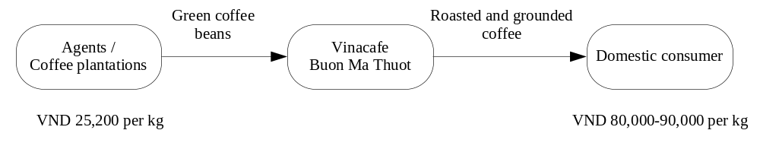

Source: Authors
Note: Exchange rate: VND 17,500 = USD 1 (22 Feb 2009)

The company specialises in trading and importing/exporting, and mainly deals with various types of Robusta coffee. It has supplied a range of diversified and high quality products – based on Robusta green coffee, roasted ground coffee, semi-washed coffee, polished coffee and coffee without black seeds, broken sticks or any other impurities – to many corporations and roasters all over the world, including Nestlé, Lavazza and Kraft.

According to an interview with the Director–General of Vinacafe BMT in 2009, production for export is about 170,000 tons to 180,000 tons per year. Of this, 60 per cent is high quality coffee. In order to collect high quality green coffee as well as develop in a stable manner, the company provides capital, fertiliser and coffee seeds to farmers in Daklak province.

All company products are managed in accordance with the “quality management system of standards” ISO 9001:2000, granted under the Bureau Veritas Certificate (formerly BVQI). The company has been awarded many quality control certificates, such as the “Pacific Asian Quality Award” by the Asia Pacific Quality Organisation.

Vinacafe BMT has a wide network of domestic suppliers, such as individual farmers, collective farms, wholesalers, agencies and small private companies (e.g. Phuc Minh Co.), so it can collect large amounts of coffee beans in a short time to meet huge orders from overseas partners. With its prestigious reputation, both its export quantity and turnover are increasing year on year (Table 14).

Table 14: Vinacafe Buon Ma Thuot’s coffee export quantity and turnover

Export | Unit | 2001 | 2002 | 2003 | 2004 | 2005 | 2006 | 2007 | 2008
Quantity | Ton | 163,858 | 155,696 | 121,141 | 174,044 | 155,000 | 170,847 | 179,000 | 164,000
Turnover | USD 1,000 | 63,954 | 50,495 | 81,543 | 111,034 | 129,000 | 202,491 | 290,000 | 334,476

Source: Vinacafe BMT (2008)

The company has exported coffee to more than 50 countries, such as the US, UK, France, Germany, Spain, Japan, Korea, Italy and Belgium. Among all the company’s export markets, Europe is the most important, with more than 50 per cent of its total export volume exported to European countries.

Table 15: Vinacafe Boun Ma Thout’s share of the coffee export market, 2001-2007

Year | Export market in tons
Year | Asia | % | Europe | % | USA | % | Others | %
2001 | 11,500 | 7 | 100,700 | 61 | 22,000 | 13 | 30,800 | 19
2002 | 8,650 | 7.5 | 70,400 | 67 | 10,400 | 9 | 26,550 | 16.5
2003 | 16,490 | 14 | 77,805 | 64 | 16,353 | 13 | 10,492 | 9
2004 | 17,523 | 10 | 88,213 | 51 | 29,673 | 17 | 38,635 | 22
2005 | 10,799 | 8 | 45,899 | 36 | 17,906 | 14 | 53,851 | 42
2006 | 43,133 | 25 | 89,777 | 53 | 23,775 | 14 | 14,162 | 8

Source: Vinacafe BMT (2009)

Figure 15: Vinacafe Buon Ma Thout’s participation in the GVC of coffee

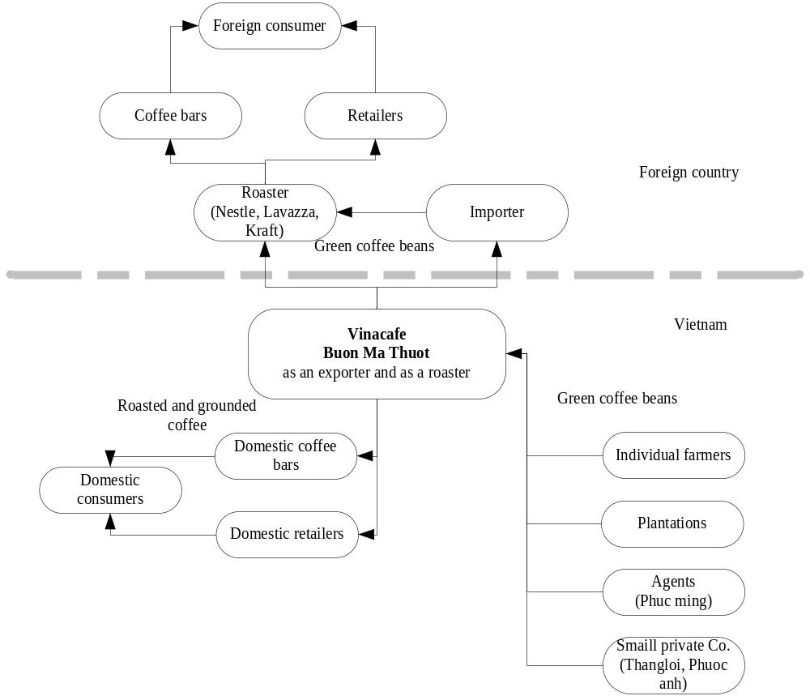
Source: Authors

The company mainly participates in the global value chain of coffee as a trader. Green bean coffee is collected by Vinacafe BMT and then classified by machine into first, second and third grade, depending on the size of the coffee grain (Table 16).

Table 16: Classification of coffee beans by size

Grade | Size | Mark | %
First | 7.1 mm | R1 18 floor | 10
Second | 6.3 mm | R1 16 floor | 40
Third | 5 mm | R2 13 floor | 50

Source: Vinacafé (2009)

After classification and processing, the coffee beans are exported.

Figure 16: Vinacafe Buon Ma Thuot’s costs and profits

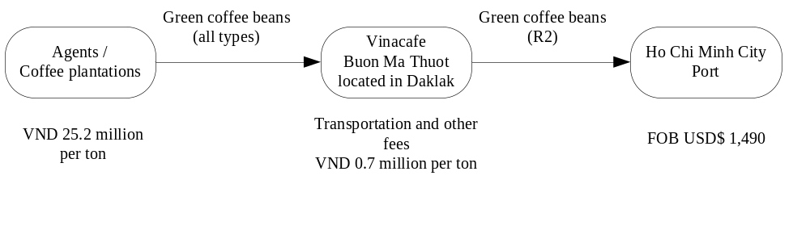
Source: Authors

The company invested VND 250,000 to build a software system in order to deal with internal management and accounting and thus allow a saving of 70 per cent on spending on administration. The company usually imports machinery from the US, Japan, EU and Brazil.

In 2007, Marubeni Corporation (a Japanese trade conglomerate) became Vinacafe BMT’s strategic partner. It has invested in the quality processing chain at the warehouse that focuses on exporting coffee to Japan only.

The company has not only been doing business, but also involved in social activities, such as participating in cooperation with local government on social policies. To date, it has spent VND 178 million on helping the poor. Besides, the company has built five houses, worth a total of VND 133 million, for the mothers of veterans and wounded soldiers, put VND 88.6 million into a fund for children and the poor in Daklak province, and contributed VND 25,000 to a scholarship fund.

The company aims to export 200,000 tons of coffee in 2009. It has negotiated with Japan’s Marubeni Corporation to set up an equally shared joint venture to produce instant coffee. The factory will be built in Binhduong province with a production capacity of 6,000 tons per year.

3.1.4.2 Case study two: Phuong Vy Coffee Company

Phuong Vy is a private family company in Ho Chi Minh City. Each family member is in charge of one sector of the company. Phuong Vy is dominant in the domestic market. Currently, it supplies about 50 per cent of domestic coffee consumption. The Phuong Vy family moved to Buonmethuot in 1954 and started working as farmers. Gradually, their firm became a small roaster, retailer, wholesaler, and then a company. After more than 50 years of hard work, it currently has 20 ha of coffee farms in Daklak province, a big factory (20,000m²) in Binhduong, and a headquarters in Ho Chi Minh City.

Phuong Vy products are sold at many supermarkets and coffee stores in Ho Chi Minh City. In 1985, it initiated a “seed to steaming cup” plan covering the full spectrum of coffee operations. In realising this plan, Phuong Vy now cultivates, harvests, processes, distributes and retails Robusta and Arabica coffees. The Phuong Vy Company also trades in semi-processed and processed coffees, and currently exports to the US, Korea, Taiwan and several European countries.

The company participates in both the domestic and global value chains. It also has two separate factories and processing lines, for domestic and export production.

The company has its own farm in Buonmethuot. It does not sign any contracts with the farmers there. It supplies land and seeds to farmers and in return gets green coffee beans at harvest. The company hires only two people to work in the farm during the year and about 300 people to collect coffee in the harvest season.

The company sells its coffee to many wholesalers who then distribute the coffee under their own brands to almost every province in Vietnam. At the moment, the company produces 30 tons per month of roasted coffee for the domestic market. It has 100 people in charge of roasting, packaging and distribution in Ho Chi Minh City.

Figure 17: Phuong Vy as a wholesaler and as a roaster

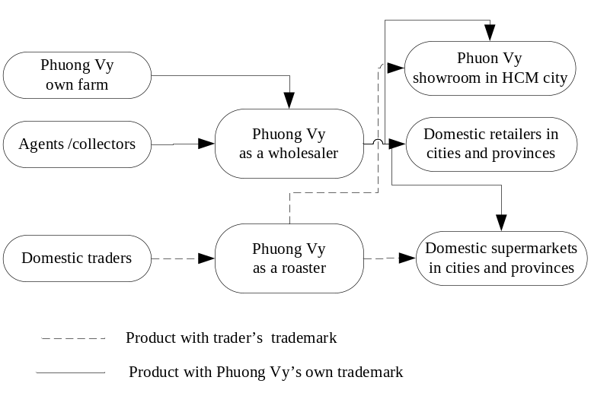

Source: Authors

The company believes it does not have the capacity to enter the world coffee market with its own brand. That is why it has chosen its position as a manufacturer in the global value chain of coffee. There are two ways in which it participates in the coffee GVC. First, it receives orders from many large international roasters, such as Nestlé, Mountain High Coffee Co., Café Caramba and Café Tostado y Molido, which it processes and then exports to the destination assigned by the international roaster. In these cases, the international roaster orders some domestic companies to supply empty coffee tins to the Phuong Vy company and then the company simply fills them with powder coffee, seals them and exports them to the US, Korea or Japan. At the moment, those empty coffee tins are produced in Vietnam, but in the future they will be imported from Malaysia at lower cost. When looking at the coffee tin, the only thing related to Vietnam the consumer can see is a sentence “Product of Vietnam”. In other words, Phuong Vy does not export coffee under its own brand.
The second way in which the company participates in the GVC of coffee consists of some international roasters with famous brand names, such as Nestle or Milo, hiring it to produce coffee under the license of their own trademarks. Those products are distributed in Vietnam.

Figure 18: Phuong Vy’s external relations

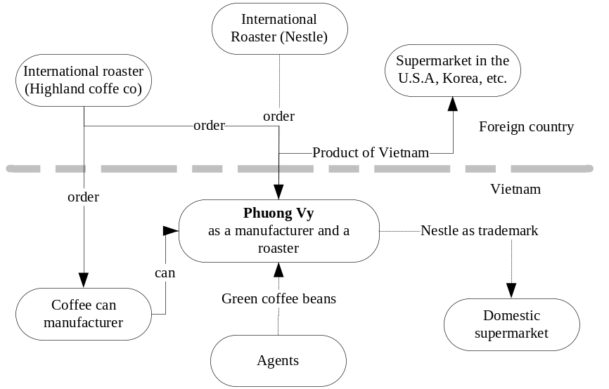
Source: Authors

The Phuong Vy Company invested a lot of money to import coffee processing lines from Germany and Brazil, including roasters and cleaning machines, but it still lacks a packing chain machine. Products are now packaged by hand or simple machine. It is currently considering importing a packing chain machine. The processing fee, which Phuong Vy receives from international roasters, is hard to indicate, as it varies in each case. According to an interview with a company manager, however, it is satisfied with its current position as a manufacturer in the coffee GVC, even though it only produces a slight added value. It understands the difficulty for a small company like Phuong Vy to enter the world coffee market directly. The manager explained that first it will take time for consumers abroad to get to know about the quality and taste of Vietnamese coffee, but that when they do, Phuong Vy will seek to get more directly involved in the world market.

Currently, Phuong Vy exports about 20 tons of coffee per month to the US, Korea, Russia, Australia, Taiwan and Japan. Its way of doing business is different: it aims to be recognised as a producer that can serve all of its clients’ demands. Therefore the company only promotes Vietnamese coffee, not yet a trademark of its own.

Regarding certification, Phuong Vy only has a quality and production certificate awarded by Vinacontrol; it does not yet have international certification because it does not have a brand name in the international market. Like other private companies, at present Phuong Vy is not a member of VICOFA, because it sees no benefits in joining.
3.2 Colombia’s participation in the GVC of coffee

3.2.1 Colombia’s coffee industry

Coffee arrived in Colombia in 1730, when the Jesuits brought the first seeds of the plant into the country (Reina et al. 2007). Tradition has it that these seeds entered the country from the east, carried by a traveller from Guyana by way of Venezuela (idem).

Colombian coffee first took root in large estates whose owners had access to international sources of credit to finance projects. Between the end of the 19th century and the beginning of the 20th, annual coffee production rose from 60,000 bags to almost 600,000 (Reina et al. 2007). During the transition from the 19th to the 20th century, the large estates were affected by a crisis which led to a transformation of the coffee industry, which involved an increase in the number of small producers and the consolidation of a new coffee export model based on a peasant economy (idem).

In 1905, only three per cent of the coffee produced in the world was Colombian, while 75 per cent was Brazilian. An attempt, led by Brazil, to control prices led the US to seek other sources of supply, and Colombia increased its production to 1.1 million bags in 1915 and an average of 4 million bags between 1935 and 1940 (Reina et al. 2007). By the 1950s, Colombia had become the second largest coffee exporter in the world.

In Colombia there are 512,000 coffee growers and more than 560,000 families make their living from growing coffee (NFC 2008). Some 640,000 people are directly employed by the coffee industry, representing 29.5 per cent of agricultural employment. The coffee industry produced 12.4 per cent of agricultural GDP in 2008 (NFC 2008).

Colombia is now the world’s third largest coffee producer and exporter, and the excellent quality of its coffee is widely recognised. This quality is made possible by the natural conditions where the coffee is grown, the washing process, the harvesting of the beans by hand, and good commercial and quality control practices (Reina et al. 2007).

Throughout its history, the Colombian coffee industry has been an important source of income for the national economy and a critical motor of social development. Thousands of coffee growers depend on coffee in Colombia. Colombian coffee is unique and, over time, a competitive infrastructure for its production and export has been developed.

3.2.1.1 Natural conditions

Colombia covers some 1,138,910 km² (113,891,000 ha). Of this, the coffee growing zone comprises 3,319,183 ha, of which 877,713 ha actually produce coffee. The natural conditions enjoyed by the coffee industry in Colombia give it an advantage over its principle competitors in Brazil, Vietnam and Indonesia. These conditions are a product of altitude, latitude, climate, soil, the surrounding environment and cultural practices (Reina et al. 2007).

Colombia is situated in the tropics and the presence of mountains rising to 5000m allows for the existence of a number of climates and conditions that favour the cultivation of coffee. The Colombian coffee growing zone is almost 3.3 million hectares in size and covers an ideal range of altitudes in mountainous regions of the country (Reina et al. 2007). Coffee is grown in three separate regions of the Andes and Sierra Nevada de Santa Marta mountains, stretching across the country from the border with Ecuador in the south to the Caribbean in the north (idem). The coffee growing areas of Colombia have dry and rainy periods distributed in such a way as to allow regular harvests of fresh coffee over the year (idem). The soil in the coffee growing areas is based on volcanic ash. This provides natural fertiliser and good physical characteristics for the production of coffee (idem).

There is one flowering period from January to March and another from July to September. The main harvest in the coffee growing areas takes places from September to December and there is a secondary harvest, known as “de mitaca”, which takes place between April and June.

A notable feature of Colombian coffee is the fact that every bean is harvested by hand and carefully washed (Reina et al. 2007). After being harvested the beans are separated into their different parts, such as the grain, the pulp and the mucilage. The pulp is removed by depulping machines that extract the grain still covered by mucilage. The grains are then classified with the aid of a sieve, in order to get the best ones. The mucilage is then removed during the fermentation process. This process involves bacteria, enzymes and yeasts, and occurs when the grains are left for 14 to 18 hours in troughs with water. The time needed depends on the location where the coffee is grown and processed. When the mucilage is removed from the grains the resulting ‘parchment’ coffee grains are then washed in clean water to remove residues and impurities (Reina et al. 2007).

The absence of technological aids in the coffee harvesting process in Colombia does not amount to a competitive disadvantage because manual grain selection allows for better quality exports. A washed Arabica variety produced in a mountainous region earns Colombian coffee the special ICO classification “Colombian mild” (Reina et al. 2007).

3.2.1.2 Infrastructure

The coffee growing area of Colombia comprises some 877,713 ha. Of Colombia’s 32 provinces, 20 produce coffee. With 126,866 ha, Antioquia is the province with the largest coffee producing area, divided between 119,152 holdings and 88,151 producers. The next largest producing area is in the province of Tolima, with 104,307 ha, 62,704 holdings and 51,560 producers, followed by Huila and Caldas provinces with 98,122 ha and 87,741 ha respectively.

Table 17 describes in detail the distribution of coffee growing in Colombia. The coffee growing area in Colombia has 611,613 holdings and 511,993 producers. 94 per cent of producers have a holding of up to five hectares. The coffee growing areas of Colombia produced a total of 12.6 million bags in 2008 (Table 17).

Coffee producers in Colombia may be categorised into four classes. In the first are those with a holding of less than one hectare; these comprise 54.4 per cent of all producers and account for 12.1 per cent of all production. The second is made up of those with holdings of between one and five hectares; these comprise 40 per cent of all producers and account for 49.8 per cent of production. The third category is made up of medium-sized producers, 3.9 per cent of the total who account for 15.5 of total production. Finally there are the large producers; these represent only 1.7 per cent of the total number of producers, but 22.6 per cent of total production (Table 17).

Table 17: Coffee production in terms of the relationship between total area sown and the size of the holding

Type of coffee grower | Size of farm (ha) | Coffee growers | Per cent of total growers | Number of farms | Farms’ area | Coffee area (ha) | Production (bags) | Per cent of the total production
Coffee growers | < 1 | 278,716 | 54.4 | 425,024 | 770,252 | 183,346 | 1,527,868 | 12.1
Small producers | 1 to 5 | 204,863 | 40.0 | 210,840 | 1,628,396 | 420,967 | 6,286,378 | 49.8
Medium producers | 5.1 to 10 | 19,710 | 3.9 | 17,790 | 416,045 | 120,617 | 1,957,999 | 15.5
Large producers | > 10 | 8,644 | 1.7 | 7,959 | 504,490 | 152,783 | 2,845,809 | 22.6
Total |  | 511,933 | 100.0 | 661,613 | 3,319,183 | 877,713 | 12,618,054 | 100.0

Source: NFC (2007)

The coffee industry in Colombia has expanded over the years. In 2004, Colombia had 94 coffee threshing machines, while in 2008 it had 132. There has been a 43 per cent increase in the quantity of coffee threshing machines over the last five years (Table 18).

Table 18: Number of coffee threshing machines in Colombia, 2004-2008

 | 2004 | 2005 | 2006 | 2007 | 2008
Number of coffee threshing machines | 92 | 118 | 117 | 121 | 132

Source: NFC (2008)

The total number of coffee roasters has risen from 148 in 2004 to 196 in 2008, an increase of 32 per cent in the last five years (Table 19).

Table 19: Number of coffee roasters in Colombia, 2004-2008

 | 2004 | 2005 | 2006 | 2007 | 2008
Number of roasters | 148 | 153 | 175 | 190 | 196

Source: NFC (2008)

Colombia currently possesses six instant coffee plants: Colcafé, Fábricas Aliadas, Buen Día, Foodex, Nestlé and another plant in the duty free zone of Cartagena.

3.2.1.3 Regulatory framework
The Coffee Policy Agreement (2008-2011) was approved by the National Committee of Coffee Growers and also has the support of Mr Álvaro Uribe, President of Colombia. It is one of the most ambitious in the history of the Colombian coffee industry and will help the industry successfully overcome the global economic crisis. Through the agreement, the coffee industry will receive economic aid worth 1.4 trillion Colombian pesos, twice the sum provided by the previous Coffee Policy Agreement (2002-2007).

The latest agreement includes an income-stabilising provision called the “Price Protection Contract” which guarantees a fixed price of 474,000 Colombia pesos (USD 199.22) per 125 kg bag to growers. This price is assumed to cover coffee production costs and the initiative is a notable addition to the current coffee policy. The new price contract option can be used by growers to secure a price for up to 50 per cent of their total anticipated production.

This agreement highlights the importance of the coffee industry as a strategic asset for the country and also the need to make it the hub of agricultural policy, democratic security and the search for equity, because of rural poverty and the predominance of smallholdings in the coffee industry.

3.2.2 Position in international markets

3.2.2.1 Coffee production

Colombia is the third largest coffee producer in the world after Brazil and Vietnam. In 2007 its production amounted to 10 per cent of world volume. Between 1980 and 2007, Colombia’s coffee production rose from 12.07 million bags to 12.61 million, an increase of 4.51 per cent (Figure 19).

Figure 19: Coffee production and exports in Colombia, 1980-2007 (thousands of bags)
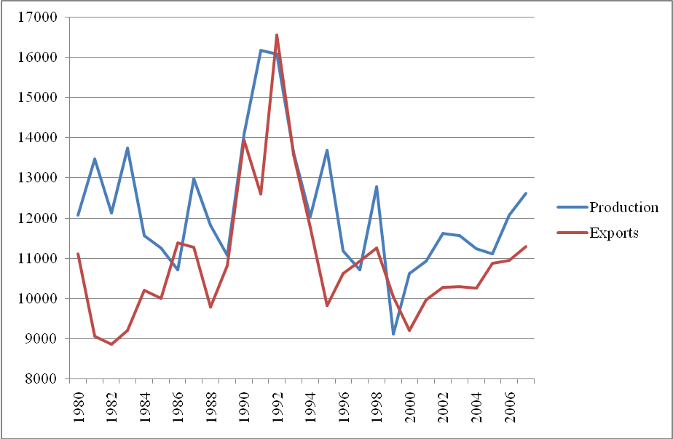
Source: NFC (2007)

In 2007, 89.56 per cent of coffee production was exported, while 10.44 per cent went to the domestic market.

Coffee processing companies have made great efforts to increase their technical and productive capacity in recent years. In 2008, 1.8 million bags of Colombian coffee were processed. Colombia mainly produces roasted coffee, with 56 per cent going to local industry, 11 per cent for instant coffee and the remaining 33 per cent for export (Figure 20).

Figure 20: Colombian national production of instant, roasted and ground coffee
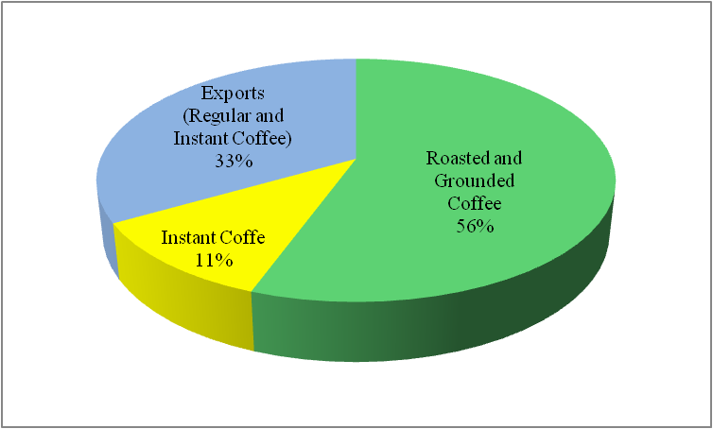
Source: data provided by Colcafé in interview in January 2009.

3.2.2.2 Coffee exports

Coffee was one of Colombia’s principle agricultural exports before 1990, and in 1991 still represented almost 50 per cent of total agricultural exports (DANE 2007). Figure 21 shows coffee exports in relation to total exports and agricultural product exports.

Figure 21: Coffee exports as a percentage of Colombia’s total and agricultural exports, 1991-2006
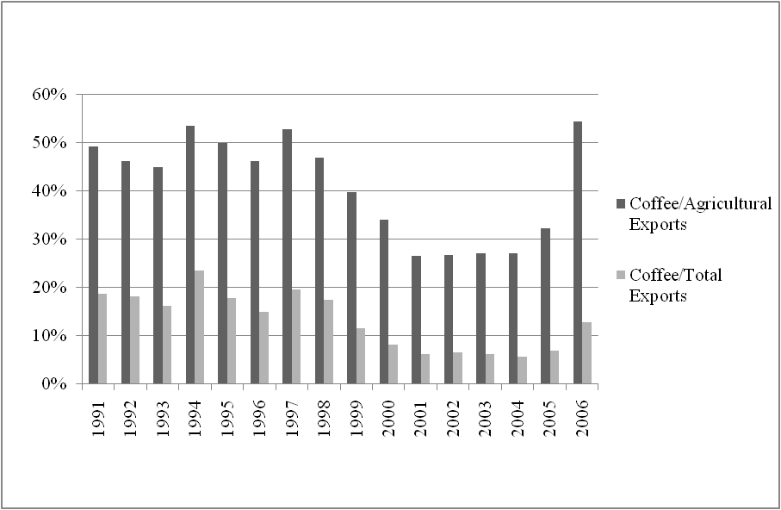
Source: Ministry of Agriculture and Rural Development (2006)

Colombia has traditionally been an exporter of grain coffee. In 2007 it exported 11.3 million bags, of which 10.7 million were green coffee, with 599,394 bags being processed (Table 22). Exports of green coffee amount to 94.7 per cent of the total; only 5.3 per cent was processed. Total Colombian coffee exports amounted to 11.76 million bags in 1994, falling to 11.3 million in 2007 (Figure 22).

Figure 22: Colombian coffee exports, 1994-2007
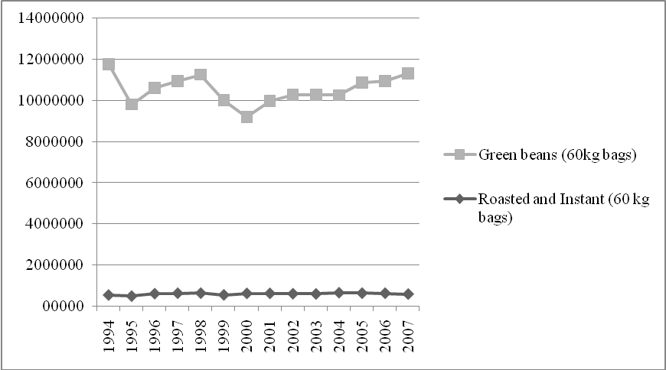
Source: NFC (2007)

The main markets for Colombian coffee are the US, Germany, Japan, Canada, Belgium and Luxembourg. The US is the main importer, with imports worth USD 371.2 million in 2006. Second came Japan with USD 163.6 million, third came Germany with USD 149.3 million and fourth came Canada with USD 61.5 million. Other important markets are Belgium, Luxemburg, Italy and the UK (Table 19).

Table 19: Main markets for Colombia coffee (thousands of USD)

Year | 1997 | 1998 | 1999 | 2000 | 2001 | 2002 | 2003 | 2004 | 2005 | 2006
US | 665,272 | 539,569 | 436,225 | 365,630 | 274,321 | 265,367 | 294,925 | 345,874 | 536,018 | 371,236
Japan | 251,468 | 190,371 | 169,269 | 155,690 | 104,197 | 123,418 | 119,409 | 161,751 | 226,848 | 163,606
Germany | 518,634 | 439,385 | 253,876 | 203,098 | 147,513 | 135,427 | 129,130 | 133,631 | 201,396 | 149,328
Canada | 77,048 | 68,584 | 51,327 | 52,307 | 43,782 | 42,239 | 42,095 | 57,617 | 93,849 | 61,519
Belgium and Luxembourg | 94,136 | 65,330 | 65,701 | 38,659 | 31,034 | 33,058 | 41,559 | 51,126 | 93,115 | 53.101
Italy | 56,075 | 44,582 | 34,154 | 28,915 | 20,805 | 20,982 | 21,241 | 27,933 | 59,584 | 40,744
UK | 48,792 | 39,699 | 29,718 | 21,454 | 16,387 | 21,314 | 20,856 | 22,273 | 44,439 | 33,720
Sweden | 80,849 | 66,856 | 40,358 | 27,986 | 22,995 | 20,443 | 19,422 | 24,360 | 36,057 | 28,899
Spain | 61,148 | 54,867 | 39,542 | 26,749 | 15,672 | 20,239 | 20,781 | 20,650 | 30,803 | 28,826
Finland | 43,175 | 39,944 | 27,204 | 12,485 | 14,977 | 14,002 | 10,842 | 17,822 | 22,321 | 23,198
TOTAL | 2,264,670 | 1,895,530 | 1,348,537 | 1,069,823 | 769,386 | 782,180 | 813,930 | 964,019 | 1,492,471 | 1,069,262
Source: Ministry of Agriculture and Rural Development (2006)

3.2.2.3 Domestic coffee consumption

Coffee consumption in Colombia has not fallen much in recent years, going from 1.22 million bags in 2003 to 1.19 million in 2007 (Figure 22). Domestic coffee consumption in Colombia represented 9.4 per cent of the nation’s production in 2007. Efforts have been made to increase domestic consumption in recent years but there remains work to do in this area (Figure 23).
Figure 23: Domestic coffee consumption in Colombia, 2003-2007 (millions of bags)
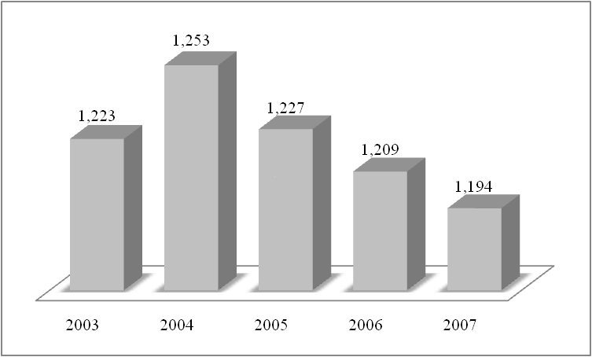
Source: NFC (2007)

Colombian consumers prefer roast and ground coffee, with 66 per cent of them choosing it as opposed to 33 per cent preferring instant coffee. Annual per capita consumption of coffee in Colombia is 1.9 kg, compared to consumption in other coffee producing countries of 5.3 kg in Brazil, 5.4 kg in Costa Rica, 2.5 kg in Costa Rica, 1.9 kg in Honduras and 0.8 kg in Mexico (Table 10).

Table 20: Per capita coffee consumption in main producing countries, 2001-2005

Year | 2001 | 2002 | 2003 | 2004 | 2005
Brazil | 4.6 | 4.6 | 4.7 | 5.1 | 5.3
Costa Rica | 3.9 | 3.7 | 3.2 | 5.2 | 5.4
Dominican Republic | 2.3 | 2.4 | 2.4 | 2.6 | 2.5
Colombia | 2.0 | 1.9 | 1.9 | 1.9 | 1.9
Honduras | 2.0 | 1.8 | 1.8 | 2.0 | 1.9
Mexico | 0.8 | 0.9 | 0.9 | 0.9 | 0.8
Source: ICO (2004, 2005, 2006)

3.2.2.4 Actors

3.2.2.4.1 Coffee growers

Coffee growers in Colombia have long shared a collective vision. As mentioned earlier, most of them have holdings of up to five hectares. The production of coffee is mainly carried out by small producers, many of whom are entirely dependent on the coffee crop and some of whom live in precarious conditions (Ministry of Agriculture and Rural Development of Colombia (MADR) 2006).
Coffee growers have adopted new technologies recommended by the National Federation of Coffee Growers of Colombia (NFC), which have led to a fall in average plant age and a rise in plant density per hectare (MADR 2006).

In Colombia, growers mainly sell their harvest to growers’ cooperatives, and also MNCs and domestic coffee exporting firms. When the coffee is sold to cooperatives, the National Coffee Fund in turn buys it from them at a price determined by international market conditions and then stores it in the warehouses of Alamacafé. The historic pattern has been for 50 per cent of the coffee harvest to be bought by the cooperatives and the other 50 per cent to be acquired by other purchasers (MADR 2006).

3.2.2.4.2 National Federation of Coffee Growers of Colombia

The NFC buys, processes and trades coffee both within Colombia itself and abroad. It is the principle face of Colombian coffee abroad and manages coffee policy inside the country each year. It has 566,000 coffee producer members and a clear vision of development for the coffee industry.

The NFC was founded in 1927 in the context of an international coffee price crisis amid the need for small producers to organise themselves and receive development and technical assistance. A key factor in the organisation’s success has been its independence from the government. The NFC represents the interests of coffee growers within the broader coffee industry.

The NFC is active in all districts, through the cooperatives that exist there. These cooperatives are the point of contact between the grower and the NFC. Apart from purchasing the harvest, the latter provides the former with assistance such as social programmes, loans, advice on new technology, education and incentives – in the form of certification – to improve the quality of the coffee. This assistance is managed in such a way as to make growers part of the institution which manages the country’s coffee policy.

The activities of the NFC make themselves felt in terms of public goods like education, health and technology transfer. The NFC also ensures that growers receive a high proportion of the international market price of coffee, a greater proportion than that received by growers in other countries (Reina et al. 2008).

3.2.2.4.3 Coffee processors

Some of the main coffee processors in Colombia are Colcafé S.A, Nestlé, Casa Luker and Torré Café Águila Roja. Each firm has an important role in the national coffee industry even if the coffee it processes is not exported in great quantities. Companies like Colcafé have star products like Sello Rojo and Sello Dorado coffees, as well as the Colcafé trademark. They have also been expanding their share of the processed coffee market, which has a high degree of added value, and although they do not compete directly with green coffee, they do so in terms of consumption (MADR 2006).

Figure 24 illustrates Colombian firms’ share of the roasted coffee market. Colcafé leads with 56 per cent of the market, followed by Torré Café Águila Roja with 21 per cent and Casa Luker with 18 per cent. Other firms supply 18 per cent of the market.

Figure 24: Market share of roasted coffee by Colombian companies, 2008
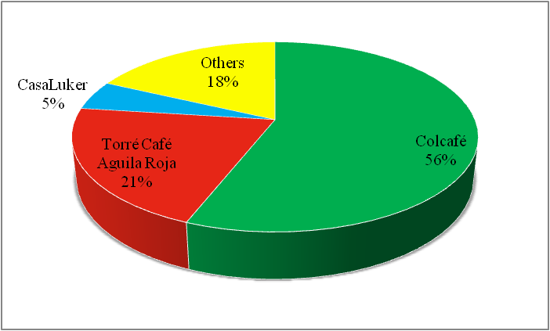
Source: data provided by Colcafé in interview in January 2009.

In the instant coffee market the picture is different. The market leader is the multinational Nestlé with 46 per cent, with Colcafé second with 39 per cent, NFC third with 5 per cent and other companies with 10 per cent of the market (Figure 25).

Figure 25: Market share of Colombian companies in the instant coffee market, 2008
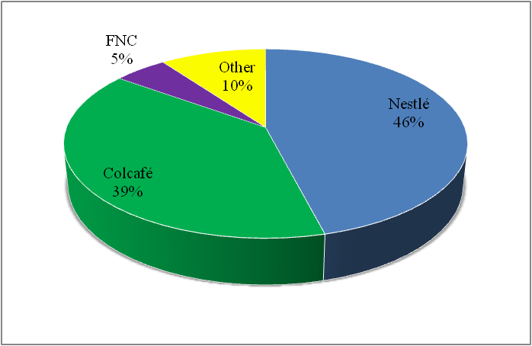
Source: data provided by Colcafé in interview in January 2009.

3.2.2.4.4 Coffee exporters

Whilst the NFC was responsible for 27 per cent of coffee exports in 2008, Colombia has other important exporters. Seven companies (Volcafé (Switzerland), Expocafé, Neuman Kaffee (Germany), Racafé, Espinosa Hermanos, the Ecom group (Switzerland) and Compañía Cafetera Agrícola) have 54 per cent of the market between them, with independent exporters accounting for 12 per cent of the market (Figure 26).

Figure 26: Percentage of market share of coffee exporters in Colombia, 1993-2007
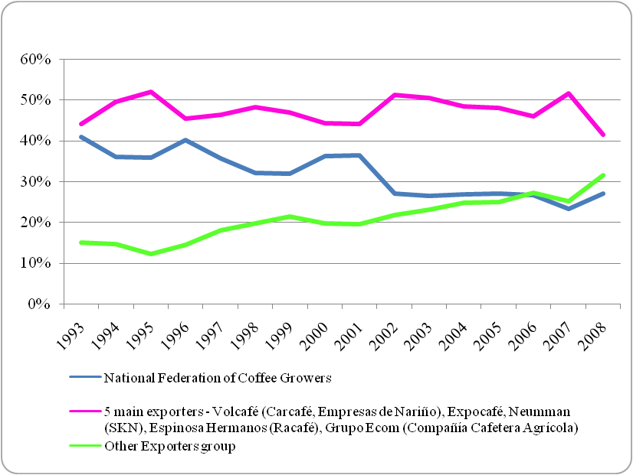
Source: NFC (2008)

3.2.2.4.5 The state

The Colombian state is an active participant in the coffee industry and regulates prices through the National Coffee Fund. It is also responsible for the quality control of exports and, through a variety of state organs such as the Ministry of Agriculture and Rural Development, it encourages research and development (R&D) in the coffee sector.

The coffee industry has an important role in the Colombian economy as a generator of employment, as a multiplier of the aggregate demand and as a support for the development of other economic sectors (Silva 2004).

The institutionalisation of the coffee industry in Colombia has been possible due to the imposition of a tax to finance it. Coordination with the government was also necessary in order to guarantee the continuity of policies and a long-term vision, consistent with macroeconomic policies. The government used its influence in the creation of the norms of the NFC through laws and decrees (Silva 2004).

The government also plays an important role for the Colombian coffee industry through a coffee price stabilising mechanism. To offset the impact of the volatility of the coffee price on farmers’ incomes, a fund was established. This fund is managed by the NFC and boosts low coffee prices with reserves held from periods of higher prices (Patrón 1995), as well as funds collected from the taxation of coffee exports (Greco 2000).

The government’s efforts to open new markets and to reduce trade barriers (such as the negotiation of a free trade agreement with the US) have had a positive impact on the coffee industry’s exports, which have greatly increased since the massive reduction of trade barriers in 1991 (Greco 2000). Nevertheless, it must be noted that coffee has decreased dramatically as a percentage of total exports, from 63.44 per cent in 1970 to 5.72 per cent in 2008.

3.2.3 Internationalisation and market innovation

Colombia was the world’s second largest producer of coffee until 1999, when it was displaced by Vietnam (Roldán-Pérez 2008), which had risen from 47th in the league table of exporting countries in 1979 to 15th in 1990 (MADR 2006).

Colombian coffee continues to enjoy a high degree of recognition on the international stage, not only for its quality but also for the trademark strategy, which has successfully emphasised the origin of the product since 1952 (Reina et al. 2008).

The manual harvesting process of Colombian coffee, combined with the washing process, is its key added value element. These factors ensure appropriate aroma, body and taste of the coffee. By way of this added value, a higher income is sought for growers and is obtained when consumers are offered innovative and high quality options at each consumption opportunity. In this regard, special coffee projects have been developed, the “Juan Valdez” shops have been consolidated and a new range of coffee-based products (such as soft drinks and coffee extracts) has been produced.

Special coffees show the diversification possibilities enjoyed by the Colombian coffee industry both at home and abroad, as well as the fact that quality is something that cannot be improvised. This strategy was put in place in 2002 and seeks to take advantage of the specific geographic, social and environmental aspects of the Colombian coffee industry. There are three categories of special coffees: coffees of origin, sustainable coffees and preparation coffees. The first category consists of coffees that come from a specific holding or region which are sold to the consumer without being mixed with coffees from other places (NFC 2009). The second category consists of coffees produced with a high degree of commitment to the environment and with an emphasis on the welfare of the families that work to produce them. Clients concerned about nature choose these coffees, which also promote fair trade with developing countries (NFC 2009). The third category consists of coffee grains of special size and appearance for which there is demand in the international market (Figure 27).

Figure 27: Types of speciality coffee from Colombia

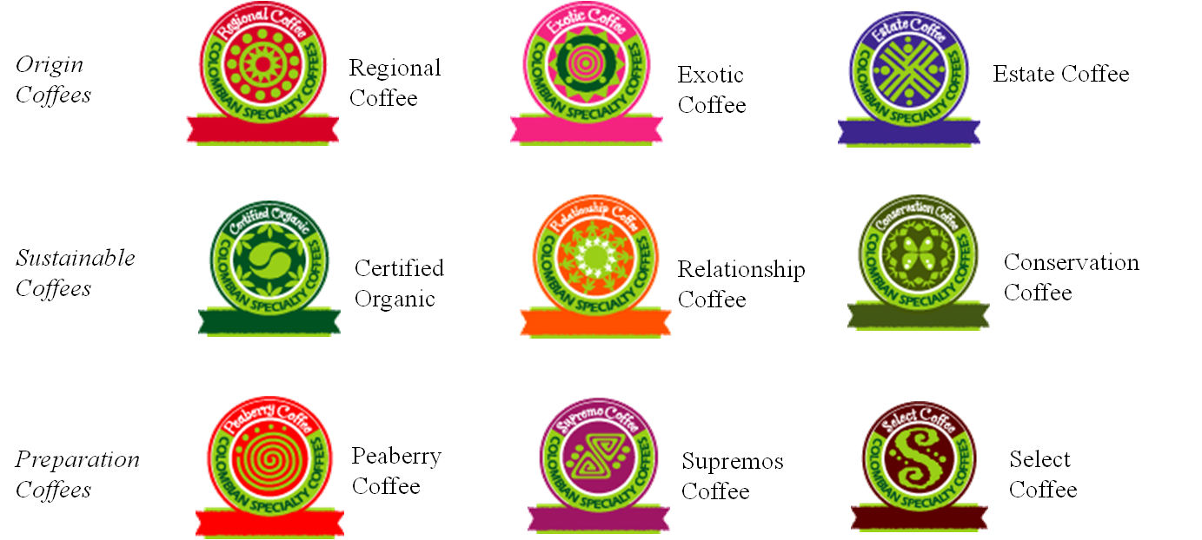
Source: NFC (2009)

These types of coffee are valued by consumers for their consistent, verifiable and sustainable attributes and these consumers are thus willing to pay a higher price for them, which in turn results in improved welfare levels for producers (NFC 2009). Colombia has distinguished itself in the management of the Colombian coffee trademark by emphasising place of origin as an attribute of the coffee offered to the world.

The “100 per cent Colombian Coffee” label was introduced to the world in 1930 when the NFC opened an office in New York City, and its launch was accompanied by a number of other strategies designed to position Colombian coffee as a superior quality product. During the development of this strategy a need for a character to strengthen clients’ positive associations with Colombian coffee was identified. To satisfy this need the NFC concentrated its efforts in developing the Juan Valdez character, the typical coffee grower of the mountains of Colombia, a grower who through his efforts and dedication manages to produce a coffee of high quality. This latter was linked to the higher price the consumer pays for Colombian coffee, demonstrated by the slogan, “The true pleasures of life are more expensive”. The launch of this character, who would go on to accompany Colombian coffee, shows the emotional connections consumers have with Juan Valdez, chosen as one of their favourite icons of the year in 2005 (Reina et al. 2007).

The Juan Valdez shops are another part of the image of Colombian coffee in the world. There are 128 of these shops in Colombia itself, 14 in the US, 8 in Spain, 9 in Chile and 7 in Ecuador (NFC 2009).

Through the abovementioned strategies of product diversification and innovation, attempts have been made to raise the level of coffee consumption in Colombia itself. On the international stage the emphasis has been on the projection of a clear image and expanding the positive vision of Colombian coffee.

3.2.4 Case studies of coffee companies in Colombia

3.2.4.1 Case study one: National Federation of Coffee Growers

The NFC is the main institution of the Colombian coffee industry. It is a private capital firm with public objectives, aiming to assure the growers’ safety and representation. Within its structure are more than 566,000 coffee growers and it is one of the best organised coffee institutions in the world.

The NFC has been a key player in the history of the development of a first class coffee bean. It was founded in 1927 as a consequence of the international market crisis at the end of the 1920s. The reasons for that crisis included:
- The high levels of stock, due to the control exercised by Brazil;
- Low consumption levels caused by high barriers for the entrance of coffee in consumer countries;
- World production exceeding consumption by nearly 30 per cent.

The coffee growers who comprise the organisation are divided into different levels. The highest level is the National Coffee Growers Congress, followed subsequently by the National Committee, the National Group, and the provincial and municipal committees, all the way down to individual members. This structure is the basis on which coffee growers elect their representatives within the organisation (Figure 28). This model enjoys international recognition and is said to be the basis for the success of the Colombian coffee industry, due in part to its independence from the state.

Figure 28: Structure of the NFC
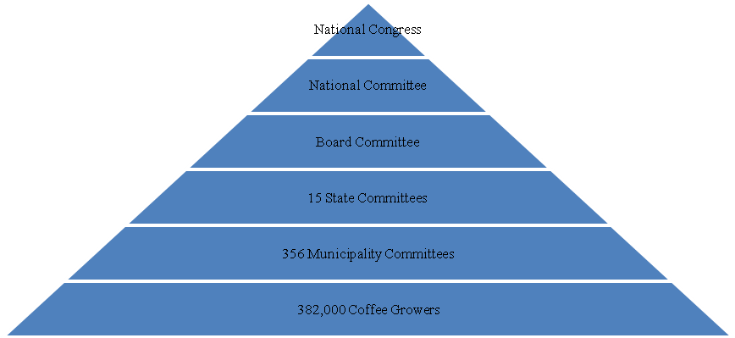
Source: NFC (2008)

The NFC also runs a number of other bodies that complement the work of the coffee grower. These include the National Coffee Research Centre (Cenicafé), the Manuel Mejía Foundation, a freeze drying plant, the National Coffee Fund, the General Warehouse, coffee growers’ cooperatives and Procafecol, which manages the Juan Valdez shops.

- Cenicafé coordinates all R&D related to coffee, from genetic studies to produce new varieties to study of the harvest in terms of yield and quality, all of which is aimed at benefiting the growers (NFC 2009).

- The Manuel Mejiá Foundation aims to provide training and education for coffee growers and their families through both on-site and distance learning programmes (NFC 2000).

- The freeze drying plant is the only one in the country. This demonstrates the technological capacity of the NFC (NFC 2009).

- The National Coffee Fund is the structure through which the federation regulates the price of coffee and protects growers from the fluctuations of international markets (NFC 2009).

- The General Warehouse (Almacafé) forms part of the logistical chain of the coffee trade. The coffee purchased by the NFC is brought to this site prior to distribution to the domestic or international market, or to being sent on for processing (NFC 2009).

- Growers’ cooperatives are social organisations owned by the coffee growers whose aim is to ensure the purchase of the coffee crop at the best market price (NFC 2009). There are 38 cooperatives in Colombia (NFC 2009).

The key to the organisation’s success lies in both its legitimacy and its professional administration and structure. It also possesses an entrepreneurial culture associated with the design and implementation of measures aimed at improving the lives of Colombian coffee growers (Reina et al. 2008).

3.2.4.2 Case study two: Colcafé S.A.

The application of the global value chain to the coffee industry does not constitute a hypothesis but rather an analytical framework (Samper 2003). As a consequence, GVC approaches focus on analysing specific questions that cannot be addressed with conventional economic analysis (Gilbert 2007).

Colcafé S.A.’s position in the value chain can be defined as the transformation of processed coffee beans into industrial and consumer products and their subsequent commercialisation, as well as the offering of tailored solutions for its business clients.

Domestically, Colcafé produces only for individual consumers and sells directly to retailers. In the GVC, Colcafé’s products are often resold and further processed, but the company is increasing its exports of consumer products.

The application of GVC concepts should be complemented with a careful assessment of the value quantifications at each stage of the value chain. As Gilbert (2007) noted, (i) the division and assignment of total value to different stages of a value chain may be misleading, especially in the case of commodities whose price tends to equal its cost in the long run; (ii) important processes which determine the value added to the product may be neglected if they occur at distant locations from the physical production; (iii) the GVC concept can lead to a false materialisation of a value chain (this can take place because many quite different activities are grouped together in order to form a GVC. While it can be a useful analytical tool, there is the danger that the classification of the activities develops its own logic, leading to distorted conclusions).

Thus, the following description of the added value at each stage of the Colcafé S.A. value chain has the purpose of providing an overview of its most important activities in terms of Colcafé S.A.’s own perspective. This description should be interpreted as an example of the coffee GVC, while bearing in mind that it should be followed by a prudent assessment of its application.

The origin of the best coffee in the world can be found at coffee growers’ smallholdings. The farmers and harvesters select every coffee bean individually, in order to apply traditional processes that guarantee the highest quality coffee with its unique, mild taste.

The NFC ensures that the beans delivered to the company meet the highest standards. Colcafé S.A.’s production process starts with the selection of the beans, so that beans with similar properties are used for the different classes of coffees produced. Afterwards the beans are roasted and further processed, either for roasted or for instant coffee.

The Colcafé S.A. R&D department is one of the fundamental value-adding areas within the company. Based upon the experience and creativity of the research personnel, as well as on its advanced technology, this department generates new knowledge. This knowledge is applied to the development of new products as well as to processes within the organisation.

The company has a number of certifications, such as ISO 9001, ISO 14001, BASC, Kosher, Fair Trade, Organic Coffees, to name just a few.

Colcafé S.A.’s internationalisation process started as early as 1961, with the company’s first export destination being the Japanese market. This was an important step for the company, especially because the Japanese market was known for its demanding nature and preference for tea.

The first export with its own brand went to Chile in 1962. Since then the Colcafé brand has successfully penetrated many markets, becoming an important element in the international expansion of the company.

Colcafé S.A.’s international presence has been accomplished either with exports or through foreign direct investment. As of today, Colcafé S.A. is present in five continents, and more than 45 countries.

3.2.5 Colombia’s participation in the GVC of coffee

Figure 29: Colombian’s participation in the GVC of coffee

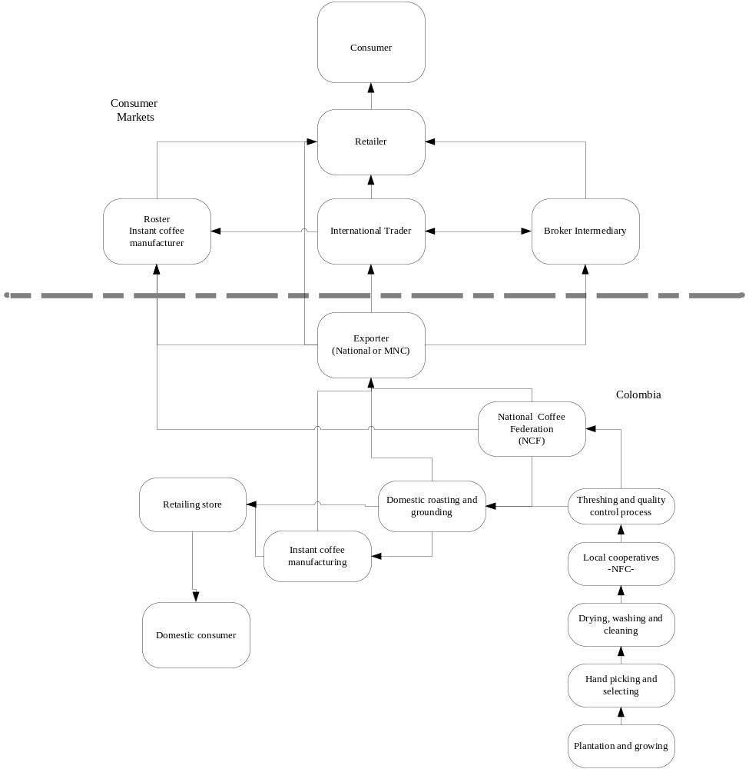
Source: Authors

In a simplified model of Colombia’s participation in the coffee GVC (Figure 29), the first stages include the artisanal processes of planting and growing the coffee plants, then hand picking and seizing, and afterwards drying, washing and cleaning the coffee beans. The process requires the farmer’s constant attention, especially in order to assure the quality of the coffee.

Local cooperatives group individual farmers together, thereby improving their bargaining power. After the threshing and quality control process, the coffee is sold either to the NFC, the most important player in the context, or to local roasting and grinding companies. The NFC sells either directly to roasters and instant coffee manufacturers, or indirectly to an exporter.

Domestic roasting and grinding companies, such as Colcafé, may channel the coffee to external markets (mainly through exporters), but they also have an important presence in the domestic market. Instant coffee requires additional processes, and can also be sold either to the external market through exporters or the domestic market.

It is possible, as described in the Colcafé case study, to sell roasted and ground or instant coffee to industrial clients. Industrial clients constitute, for example, roasters and instant coffee manufacturers or intermediaries. On the other hand, there is the possibility of achieving a higher added value: either through third party manufacturing or through reaching the external markets directly with an own brand.

The exporter channels the coffee either through roasters and instant coffee manufacturers, international traders, or other brokers or intermediaries, but also directly to retailers. These different international players can also interact with each other.

The final consumer, either in the domestic market or in an external context, is served mainly by retailers. Two distinctions can be made to this: firstly, as mentioned earlier, the consumer is served either through domestic or foreign brands; secondly, another important distinction is related to the percentage of Colombian coffee in the final mix, as intermediaries, roasters or instant coffee manufactures may combine coffee from different locations.
3.3 Comparative analysis of Vietnam and Colombia’s participation in the GVC of coffee

3.3.1 Coffee industry environment

Vietnam and Colombia are both endowed with specific natural characteristics and use manual picking as a regular practice for harvesting. Nonetheless, there are natural and environmental conditions that make Vietnam more suitable for Robusta coffee and Colombia for Arabica. There are also different harvesting seasons caused by weather conditions in the two countries. In Vietnam, the flowering period is from March to May and harvested from November to January or February. In Colombia, meanwhile, there are two flowering periods, one from January to March and the other from July to September. The main harvest in the coffee growing areas takes places from September to December and there is a secondary harvest from April to June.

Although coffee is not native to either Colombia or Vietnam, both countries have a long history of coffee growing. Coffee was introduced in both countries in colonial times: to Colombia in 1730 and Vietnam in 1857. This has not only provided experience in growing and processing, but has also developed institutions around the coffee industry, and furthermore has created a favourable domestic market for coffee consumption.

In the S-shaped country of Vietnam, coffee growing areas are concentrated in the central highland provinces such as Lam Dong, Daklak, while in Colombia, coffee is grown in 20 out of 32 provinces. However, their total coffee growing areas are 506,000 ha in Vietnam and 877,713 ha in Colombia.

In terms of infrastructure, the coffee industry in both countries is characterised by many farmers cultivating a small area of land, typically less than 5 ha per household.

In terms of domestic market, there are many differences between the two countries. Vietnam’s domestic market consumes around 5 per cent of its total production while that figure is up to 10 per cent in Colombia. The underlying reason is that the consumption level per capita in Vietnam of 0.5kg per annum is much lower than the 1.9kg consumed per capita in Colombia. However, due to the efforts of both governments and marketing campaigns by national coffee companies, domestic consumption in both countries is expected to increase. According to face-to-face interviews with marketing managers carried out in Colombia, domestic consumers are increasingly more concerned about health-related issues and their relationship with coffee consumption. Coffee companies in Colombia have been allocating significant resources to scientific research to evaluate the impact of coffee on human health. Findings from this research have resulted in the design of innovative improvements to reduce the gastric impact of coffee. Varieties of both instant and ground decaffeinated coffee have been developed with increased pH levels, in order to reduce the acidity in the coffee. Regarding cardio-vascular impact, recent research commissioned by Colombian coffee producers showed that cardio-vascular risks are lower for decaffeinated coffee.

3.3.2 Position in global markets

Vietnam is the second largest producer of green coffee bean in the world after Brazil. In 2007 its production amounted to 15 per cent of world volume (Table 1 above), whereas Colombia is the third largest producer, representing 10 per cent of world volume. As discussed, the countries differ in the type of coffee produced, with Colombia producing Arabica while Vietnam produces Robusta (though it has recently promoted Arabica production).

3.3.2.1 Coffee exports

Before 1990, Colombia’s exports relied heavily on coffee, but by 2007 Colombian coffee exports represented only 5.7 per cent of total exports. In the same way, even though coffee exports in Vietnam are very important for the welfare of its people, Vietnam’s coffee exports accounted for 10.28 per cent of exports in 1995, falling to 3.87 per cent of exports in 2007.

Colombia has traditionally been an exporter of coffee. In contrast, Vietnam only appeared in the coffee export market in the 1990s. In 1995, Vietnam’s coffee exports were only 3.53 million bags (212 million tons), while Colombian coffee exports were 9.81 million bags. According to export figures from both countries, Vietnam displaced Colombia to become the second largest coffee exporter in the world in 2000. By 2007, Vietnam was exporting 18.87 million bags, increasing its participation in the international market impressively, while Colombia maintained its position exporting 11.3 million bags.

Both countries mainly export green coffee beans. In 2007, Colombia’s green coffee bean exports were 94.7 per cent of total coffee exports, while processed coffee (both roasted and instant coffee) only represented 5.3 per cent of the total. In the same way, Vietnam’s green coffee bean exports were 95 per cent of total coffee exports, with processed coffee making up the rest (1-2 per cent roasted coffee and 3-4 per cent instant coffee). Colombia and Vietnam are trying to boost their participation in processed coffee both domestically and internationally, though it is difficult to increase the export quantity of processed coffee in global markets due to the large competition from famous coffee brands.

In Colombia, coffee exports are concentrated in the National Federation of Colombian Coffee Growers and five major exporters. Colcafé is an important exporter of processed coffee. In Vietnam, there are around 150 exporters, but coffee exports are highly concentrated in few exporters such as Vinacafe.

Although Vietnam and Colombia export different type of coffee, both countries compete in the international market because green coffee beans are the raw material for big roasters and MNCs in consumer markets.

Coffee prices vary daily and are determined by supply and demand. In 1999, world production increased rapidly and prices dropped, mainly because of the new production areas in Brazil that improved its output, combined with new planting and rapid production growth in Vietnam. Coffee export prices diverge considerably in Colombia and Vietnam, with Vietnam’s export prices being lower than Colombia’s. Referring to Table 12 above, the Robusta daily average price increased from 27.54 US cents per pound in 2001 to 105.28 US cents per pound in 2008, while the daily weighted average price of Colombian mild Arabica climbed from 72.05 US cents per pound in 2001 to 144.32 US cents per pound in 2008. The international coffee price for Colombian mild Arabica is 37 per cent higher than the price for Robusta. This is one of the main reasons that Vietnam is making efforts to change some of its Robusta plantations to Arabica ones.

According to the type of coffee they produce, Colombia and Vietnam diverge in their market share of the main coffee export markets. For instance, Colombia’s five main markets are: the US, Japan, Germany, Canada, and Belgium and Luxembourg. Only three countries – the US, Japan and Germany – buy 64 per cent of Colombia’s coffee.

Meanwhile, Vietnam’s five main markets are: Germany, Spain, the US, Italy and Poland. Germany is the main market for Vietnam, accounting for 14.5 per cent of total coffee exports, followed by Spain (11.28 per cent), the US (11.20 per cent), Italy (7.15 per cent) and Poland (5.16 per cent). European countries are the largest importers of Vietnam’s coffee, representing approximately 40 per cent of the total.

3.3.2.2 Domestic coffee consumption

Despite the long coffee tradition in Colombia, domestic coffee consumption only represented 9.4 per cent of the nation’s production in 2007. Coffee consumption in Colombia has been around 1.2 million bags per year over the last five years.

Coffee consumption in Vietnam is less than in Colombia. Interviews with experts estimated that domestic consumption is around 5 per cent of the total production, about 800,000 bags. However, domestic consumption has been increasing in recent years, reaching some 60,000 tons in 2005.

Domestic per capita consumption also differs considerably in both countries. While the figure in Colombia is 1.9 kg per year, it is around 0.5 kg per year in Vietnam. In both countries domestic consumption is lower than other consumer countries such as Finland, the US and Germany, or even the consumption in producing countries such as Brazil and Mexico. Coffee consumption in Vietnam is lower due to the strong tea tradition that has influenced consumption patterns over the years. This trend will change in the future due to the rapid proliferation of coffee shops and the changes in consumption patterns in the world.

Colombian consumers prefer to drink roasted and ground coffee, and coffee is widely consumed in the whole country. In Vietnam the southern region has a higher per capita consumption than the northern region.

Some important facts have lately influenced major changes in world coffee consumption, particularly in Colombia and Vietnam. First, the growth in income in different countries is a primary driver of long-term consumption (along with urbanisation and other social changes in both developed and developing countries). Second, roasters are able to incorporate a wide range of coffees into blends due to technological developments, such as the steam process. Third, most major roasters have demonstrated a willingness to switch the constituent coffee in their blends in order to have access to broader raw materials available at a wide range of prices. Fourth, brand name coffees are fighting for shares in different markets while new consumers are simultaneously entering the market, attracted by new coffee products. Traditional products are stagnating and new products are gaining more market space, such as different coffee flavours. Fifth, coffee is available everywhere in major consumer countries, where supermarkets and other retailers are increasing their market dominance. Coffee shops are also growing and are highly visible in major cities.

3.4 The participation of Vietnam and Colombia in the GVC of coffee

Vietnam and Colombia participate in different segments of the world coffee market. Vietnam is in the low-price Robusta market segment, and starting to join the instant coffee segment. On the contrary, Colombia is in the high-price Arabica segment and has a strong position in instant coffee exporting. In addition, Colombia has successfully developed some coffee specialties. Vietnam has only a minor market on its “weasel” coffee, which is currently artificially produced, and is also beginning to identify possibilities to produce “culi” coffee as an added value variety of Robusta.

Nestlé has invested in and possesses a large share in instant coffee production in both countries, some 46 per cent and 33 per cent in Colombia and Vietnam respectively. Nestlé is thus the largest instant coffee producer in Colombia, followed by Colcafé, but only the second largest in Vietnam, behind Vinacafe, which has 50 per cent of the market share. This situation reflects the dominance of MNCs in the world coffee industry, especially brand-named instant coffee.

4 Conclusions and recommendations

The following table summarises the comparison between Colombia and Vietnam.

Table 21: Comparison of Colombia and Vietnam’s coffee industries using the observation protocol

 |  | COLOMBIA | VIETNAM
INFRASTRUCTURE
Economy
 | GDP (2008) | USD 378.6 billion | USD 70.1 billion
 | % exports (2008) | USD 41.08 billion FOB  10.85% | USD 62.9 billion FOB  89.73%
Population and employment
 | Total population | 47 million | 86 million
 | Total employment in the coffee industry | Coffee growers: 511,933 | 600,000 coffee growers.
 | % adult literacy | 92.8% can read and write | ..
 | Average school level for workers in the coffee industry (farms) | .. | ..
 | % of workers who are landowners | .. | ..
 | Number of workers associated to a cooperative | Approximately 90,000* | ..
 | % workers with permanent contract | 90%-95% do not have permanent contract, they work only according to the crop season | ..
Geographical aspects
 | Land conditions (height above sea level, level of rainfall, climate, etc.) | Arabica coffee growth altitude up to 2,500m. More than 80 micro climes in Colombia. Tropical zone. | ..
 | Production regions | Antioquia: 126,866 ha  Tolima: 104,307 ha  Huila: 98,122 ha  Caldas: 87,741 ha  Valle: 82,449 ha | Provinces in central Vietnam such as Daklak, Lam Dong, …
 | Total area of production (hectares) | Farm area: 3,319,183 ha  Cultivated area: 877,713 ha | Cultivated area: 506,000 ha
 | Number of farms | 661,613 | 300,000
 | Average total area per farm | 1-5 ha (94.4%) | 2-5 ha
 | Roads | Main roads conduct the “excelso” coffee to the main ports: Buenaventura, Cartagena and Santa Marta.  Coffee growers use small rural road (“veredales”) to transport their coffee from the farm to cooperatives or other buyers.* | Coffee beans are transported from the central provinces to Binh Duong provinces for processing, then exported through Saigon port.
History of the coffee industry
 | Date of creation | First coffee plantation 1730- historical growth by 1950s | First coffee plantation in 1857 in French colony
 | Management system/style | Cooperatives | ..
 | Number of owned farms | 661,613 | ..
 | Number of owned thresher | 132 (2008) | ..
 | Cultivated area | 877,713 (2008) | 506,000 ha
 | Associations of coffee providers | 38 cooperatives and 494 purchasing centers* | No
 | Number of employees | 511,133 coffee growers | 600,000 coffee growers
 | Forms of workers representation | Cooperatives | ..
 | % of employees who are part of a trade union | .. | ..
 | Corporate organisation | .. | ..
 | Economic indicators (net profit, sales, etc) | Total production: 12.6 million bags (2007)  Total exports: 11. 3 million bags (2007) | Total production: 57.6 million bags (2007)  Total exports: 53.8 million bags (2007)
 | Number of total employees | 640,000 direct employment | ..
 | Number of workers with permanent contract | 90%-95% have not permanent contract, they work only according to the crop season | ..
 | Production capacity (farms, processing mills, etc,) | 1-5 ha, average farm area: 1,628,396 ha | ..
 | Exports (total exports, % exports against total production). | Total production: 12.6 million bags (2007)  Total exports: 11.3 million bags (2007)  % participation of exports in the total production: 89.56% | Total production 961 million tons (2007)  Total export 897 million tons (2007).  % participation of exports in the total production : 93.34%
 | Growth in the last 10 years | (1998-2007): 0.3% | (1998-2008) 14%
 | Market projections in the next 10 years | Increase speciality coffee production | Increase domestic consumption  shift from Robusta to Arabica coffee types
 | Market positioning | Main exports (2006)  - USA: 35%  - Japan: 15%  - Germany: 14%  - Canada: 6%  - Belgium and Luxembourg: 5% | Main export (2006)  1. Germany: 19.9%  2. USA; 16.4%  3. Spain 11.2:%  4. Italia: 10.1%  5. Belgium: 3.4%

ACTORS AND REACTION TO EXTERNAL SHOCKS
 | Climate change |  | Coffee must grow in temperatures of 17 to 23 degrees centigrade. | Suitable weather conditions for coffee growing: 19-24 degrees centigrade, raining level 1500-200mm per annum, height 800-2500m above sea.
 | Fluctuation of foreign currencies |  | Calculation of price indicators (ICO composite indicator price)  Colombian mild Arabicas: New York, Bremen/Hamburg. New York 40% Germany 60%. | Vietnamese coffee’s price fluctuated according to the price in London market, but always lower.
 | International policies |  | The ICO is the main intergovernmental organisation of coffee, gathering producing and consuming countries to deal with the challenges of the world coffee sector through international cooperation. | The ICO is the main intergovernmental organisation of coffee, gathering producing and consuming countries to deal with the challenges of the world coffee sector through international cooperation.
 | Trends in consumer countries |  | Main consumption markets :  (million bags) 2007  USA 21.04  Brazil 16.09  Germany 8.62  Japan 7.28  Italy 5.79  France 5.60  Main Per-capita consumers (kg/year) 2007  Luxemburg 16.65  Finland 12.01  Norway 9.85  Denmark 8.75  Netherlands 8.62 | Main consumption markets :  (million bags) 2007  USA 21.04  Brazil 16.09  Germany 8.62  Japan 7.28  Italy 5.79  France 5.60  Main Per-capita consumers (kg/year) 2007  Luxemburg 16.65  Finland 12.01  Norway 9.85  Denmark 8.75  Netherlands 8.62
 | International civil society |  | .. | ..
 |  | Social movements | .. | ..
 |  | NGOs | .. | ..
 |  | Trade Unions | .. | ..
NEW TECHNOLOGY ADOPTION
 | Linkages with research centres |  | Cenicafé  Ministry of Agriculture and Rural Development. | No
 | Foreign technology’s adoption |  | Technology from: Brazil, Germany, Italy, Japan, Canada and the US* | Technology from Brazil, Germany, the US, Japan
 | Research and Development |  | Cenicafé  Recinto del pensamiento | No
 | Technology applied to productive processes |  | Technology from: Brazil, Germany, Italy, Japan, Canada and the US* | Technology from Brazil, Germany, the US, Japan
 |  | Planning and picking technologies | Manual | Manual
 |  | Bean improvement technology | .. | ..
 |  | Processing mills technology | Technology from: Brazil, Germany, Italy, Japan, Canada and the US* | ..
 | Roasters |  | 196 | ..
 | Local collector centres (cooperatives, etc) |  | 38 and 494 purchasing centres | ..
ADDED VALUE
 | Certifications |  | Rainforest  Fair trade  UTZ Certified  USDA Organic | ..
 | Types of coffee |  | Arabica Colombian Mild | Robusta
 |  | Speciality coffee | 1.Origin coffees: regional coffee, exotic coffee, state coffee  2. Sustainable Coffees: certified organic, relationship coffee, conservation coffee  3. Preparation coffees: peaberry coffee, supremos coffee, select coffee. | Traditional coffee:  “Culi” coffee  Weasel coffee
POSITIONING IN DOMESTIC AND GLOBAL MARKETS
 | 5 main International markets |  | USA, Japan, Germany, Canada, Belgium and Luxembourg | Germany, USA, Spain, Italia, Belgium
 | Main competitors (countries) |  | Brazil, Vietnam, Indonesia. | Brazil, Colombia, Indonesia
INTERNATIONALISATION PATTERNS
 | Alliances-Joint Ventures with traders –retailers |  | Procafecol has alliances with: - Coffee Arabicas Beverages S.A, production and distribution alliance of “colas de café”.  - Pod Col Coffee Ltda (PCC Ltda), production alliance of Pods.  - Cafescol Tiendas SL, for the creation of Juan Valdez’s stores in Spain.  -NFCGC Investment Inc, for the creation of Juan Valdez´s stores in USA*. | ..
 | Alliances-Joint Ventures with multinationals |  | Alliance with Mitsubishi to penetrate Japanese market.  Alliance between NFC and Coca Cola company, Distribution alliance* | ..
 | Alliances-Joint Ventures with roasters |  | .. | ..

MARKETING AND BRAND INNOVATION
 | Country Brands |  | NFC: Juan Valdez different type of coffees, freeze dried coffee (from Buen Día factory).  Colcafé: Sello Rojo and Sello dorado.  Torré café Águila Roja: Águila Roja.  Casa Luker: Lukafe and New Colony | TrungNguyen (ground roasted coffee), G7 and Moment (instant coffee)
 |  | Origen Denomination | 100% Colombian coffee  Juan Valdez‘s brands like: Cundinamarca, Huila, Amazónico, Guajira and Nariño. They Represent the different coffee departments of Colombia | ..
 |  | 100% coffee of XXX | Trademark for all the coffee exports “100% Colombian coffee” | No
 |  | Specific Brands | .. | ..
Regulatory frameworks and policies
 | Government legislation regarding coffee |  | .. | ..
 |  | Agricultural legislation | .. | ..
 |  | Environmental legislation | Same applied to all industries. | Same applied to all industries.
 |  | Labour legislation | Same applied to all industries. | Same applied to all industries.
 | National Association of Coffee Growers |  | NFC | VICOFA
 | Certifications (national and internationals) |  | ISO 14001Enviromental Management system  Rainforest Alliance  Kosher  Fair trade  Utz Certified  USDA Organic | ISO 9000
*Information based on Interviews with expert of the NFC and Andes cooperative, 2009.

4.1 Cooperation and competition between Colombia and Vietnam

Colombian coffee is highly different from Vietnamese coffee. Colombian coffee has exceptional natural conditions that constitute an important competitive advantage. Characteristics such as altitude and soil quality, different climates within the country and management techniques from planting to threshing, give Colombian coffee a merited reputation as the mildest coffee on earth.

Vietnam also has favourable soil and weather conditions for growing coffee, especially in the “bazan” soil highlands of the central provinces.

Colombia is the only producer country in the world with an institution that represents the coffee sector domestically and internationally. The National Federation of Coffee Growers is an important institutional actor, guaranteeing the welfare for and progress of the whole coffee industry in the country. The NFC constantly looks to transfer most of the price to coffee growers, provides them agricultural expertise and institutes measures of quality control to assure a consistently superior coffee for export. Additionally, the NFC promotes Colombian coffee’s position in international markets. Therefore, the NFC has been a key element of the development of the industry in Colombia.

The Colombian economy used to depend extensively on coffee. Nowadays coffee exports make up less than 6 per cent of the total Colombian exports. Nevertheless, coffee is very important for the Colombian economy and provides income to thousands of people in the country. The coffee tradition is still significant and many towns were built due to the coffee industry. The change in the structure of Colombian exports in recent years is due to the increase of non-traditional exports.

Like most coffee producers in the world, Colombia mainly exports green coffee beans. However, the NFC is trying to promote different kinds of speciality coffee, adding value to the grain. Additionally, some companies have succeeded in processing coffee, adding even more value to coffee; this is evidenced by the growing numbers of threshing machines, roasters and instant coffee plants over the last five years. With different types of coffee grown, Robusta and Arabica, harvested in different season, Vietnam and Colombia could cooperate to sell in both countries. In addition, the two countries could cooperate to produce instant coffee. By mixing Robusta and Arabica coffee, many kinds of instant coffee could be produced to satisfy all customers.
To some extent, Vietnam and Colombia are competing in some markets such as the EU and the US, the largest coffee markets in the world. Further research should be undertaken to analyse the competitiveness of the two countries in these markets. However, because of the different types of coffee exported, the competition between the two countries does not seem to be very intense.

Colombia cannot compete with Vietnam in terms of production costs. First of all, Vietnam is located in a more geo-strategic position than Colombia to access the Asian and Australian markets. Due its location, transportation costs from Vietnam are far lower than from Colombia. Also, there is a closer cultural proximity between Vietnam and other Asian countries, which might facilitate negotiations. Furthermore, production costs in Vietnam are lower than in Colombia. Production costs are affected by factors such as land loans by the Vietnamese government for farmers to cultivate and harvest coffee free of charge for periods of up to 50 years. Besides, labour costs in Vietnam are much lower than in Colombia.

Although it was not discussed above, it is important to note that both countries face challenges to improve labour conditions. For instance, permanent contracts for coffee pickers are non-existent for the vast majority of workers in both countries. The issue of child labour is far more evident in Vietnam than in Colombia, where the Colombian government, together with the main actors of the industry, have made substantial efforts to eradicate child labour. Commitment to workers’ health and safety seems to be higher in Colombia than in Vietnam. The significant practices of adopting international certifications and continuous monitoring systems in Colombia have perhaps positively influenced the embedding of health and safety practices. Conversely, workers lacking protection equipment, and working even without shoes, were observed during the fieldwork in Vietnam.

As a consequence, although Vietnam has and probably will continue to have competitive advantages because of its low production costs, Colombia has a competitive advantage over Vietnam regarding its social and environmental practices. Thus, even though Colombian coffee is more expensive to produce than Vietnamese coffee, it has a premium in relation to the environment and rural communities.

In terms of technological innovation, Colombia’s national research centre on coffee (Cenicafé) conducts world-class research on coffee resistance to climate conditions and diseases. Vietnam lacks such an institution. Vietnam might consider the development of its own national research centre, or it could potentially commission research from the well-established Colombian Cenicafé.

4.2 Recommendations to Colombia

Despite being the world’s third largest coffee producer, Colombia’s domestic consumption is still very small compared to Brazil’s, which is over 50 per cent of its total production. Colombia’s coffee industry should invest in advertising and coffee promotion, focusing on the positive association with coffee growers. Since coffee in Columbia is usually drunk at home, television and press advertising should be an effective means to increase per capita consumption.

If Colombia wants to continue being one of the main producers and exporters of coffee in the world, the country has to form strategies to create more added value to Colombian coffee domestically. The coffee industry also has to respond assertively to new competitors in the international environment, from countries such as Vietnam.

The world coffee market is very dynamic: consumer countries are becoming more sophisticated, demanding quality from the raw material itself, its industrial process, logistics, preparation and service to the final consumer. The Colombian coffee industry should be aware that it must take advantage of its strengths in order to compete with coffee from other origins.

Efforts made by the NFC with the brand Juan Valdez have been productive and valuable, but Colombian coffee should find other ways to advertise and promote different Colombian coffee brands internationally. If the Colombian instant coffee brands want to adjust Colombian coffee to the international demand, the industry should be willing to include coffee from different origins, and other than Arabica, in its blends. In this regard, Vietnam could be a good alternative for those companies.

It is an imperative for Colombia to increase its domestic consumption. To achieve this, Colombia’s coffee industry should focus on its current and potential consumers, linking consumption to production. There are key aspects in which marketing campaigns should be focused in Colombia.

It is critical to formalise proactive education to potential and new consumers on the impact of the coffee industry on the environment, communities and the socio-economic development of Colombia. Coffee marketers should use the long tradition of coffee consumption in Colombia, the established cooperation and commitment of coffee producers to improve the lives of those involved in the industry, and the well-developed country brand to maximise product identification. Conscious and future consumers will demand further information on production practices, such as where and how the coffee was produced, and the coffee industry must be ready to be accountable to these socially and environmentally committed demands.

Consumers should be informed of the negative effects of coffee consumption. However, continuous and independent scientific research on behavioural patterns, and the physiological aspects of consumption, should be permanently carried out. Findings of these research studies should result in further R&D to minimise any negative health impacts.

4.3 Recommendations to Vietnam

Vietnam should establish a cooperation mechanism between coffee growers and producers, especially individual farmers. In Vietnam, VICOFA is currently an association of coffee exporters, so coffee producers are not represented by VICOFA. This leads to the vulnerability of farmers to external changes in the world market. The operation of the National Federation of Coffee Growers in Colombia, with different representative layers from the grassroots up to the national level, can be an example to Vietnam.

Vietnam is well known in the world in terms of coffee quality, but does not have a national trademark for coffee. Vietnam should consider a label similar to Colombia’s “100 per cent Colombian coffee” label.

Although Vietnam’s government is encouraging the transition from Robusta to Arabica varieties to improve added value, some businesses are afraid of unsuitable weather conditions in Vietnam, as well as the expensive investment needed to process Arabica. In addition, the transition will lead to direct competition with Colombia. Rather than shifting to Arabica, Vietnam should build coffee specialties. Vietnam already has some experience of coffee specialisation, for example with “culi” coffee. Development of coffee specialities will enhance the added value and avoid competition with other exporters.

In the instant coffee market segment, expensive investment in processing facilities and marketing activities are the reasons that there are only a few large trademarks in Colombia and the rest of the world, such as Nestlé. However, in Vietnam, many companies are planning to enter this segment. This decision needs to be considered carefully because Vietnam already has some successful instant coffee trademarks, such as Vinacafe, Nestle, G7 and Moment.

Appendix: developed research instrument

Basic Information

Name:
Company/Organisation:
Position:
E-mail: |  |  |  | Telephone:
Address:

Location (region, municipality, city): |  |  |  | Region:
Country:
First contact: | DD-MM-YY | Interviewed on: | DD-MM-YY |  | Last contacted on: | DD-MM-YY

Agreements

 Total Anonymity  Name Change  Video recording  Video recording with distorted image Voice recording  Photograph  Send report before its been published  Send copy of collected data  Meeting to discuss final results  Other:

Interview and observation protocol

 |  |  | Direct Observation | Explored via interview | Secondary data is required (details) | Comments
Infrastructure
 | National Economy
 |  | GDP
 |  | % exports
 | Population and employment
 |  | Total population
 |  | Total employment in the coffee industry
 |  | % Adult Literacy
 |  | Average schooling level for workers in the coffee industry (production)
 |  | % of workers who are landowners
 |  | % workers associated to a cooperative
 |  | % workers with permanent contract
 | Geographical aspects
 |  | Land conditions (height above sea level, level of rainfall, climate, etc.)
 |  | Production Regions
 |  | Total area of production (km²)
 |  | Number of farms
 |  | Average total area per farm
 |  | Roads
 | History of the company
 |  | Date of creation
 |  | Management system/style
 |  | Number of owned farms
 |  | Number of owned thresher
 |  | Cultivated area
 |  | Associations of coffee providers
 |  | Number of employees
 |  | Forms of workers representation
 |  | % of employees who are part of a trade union
 |  | Corporate organisation
 |  | Economic indicators (net profit, sales, etc)
 |  | Number of total employees
 |  | Number of workers with permanent contract
 |  | Production capacity (farm, processing factory, etc,)
 |  | Exports (total exports, % exports against total production).
 |  | Growth in the last 10 years
 |  | Market projections in the next 10years
 |  | Market positioning
Actors and reaction to external shocks
 | Climate change
 | Fluctuation of foreign currencies
 | International policies
 | Trends in consumer countries
 | International civil society
 |  | Social movements
 |  | NGOs
 |  | Trade Unions
New technology adoption
 | Linkages with research centres
 | Foreign technology’s adoption
 | Research and Development
 | Technology applied to productive processes
 |  | Planning and picking technologies
 |  | Bean improvement technology
 |  | Thresher technology
 | Roasters
 | Local collector centres (cooperatives, etc)
Added value
 | Certifications
 | Types of coffee
 |  | Speciality coffee
Positioning in domestic and global markets
 | 5 main International markets
 | Main competitors (countries)
Internationalisation patterns
 | Alliances-Joint Ventures with traders –retailers
 | Alliances-Joint Ventures with multinationals
 | Alliances-Joint Ventures with roasters
Marketing and brand innovation
 | Country Brands
 |  | Origen Denomination
 |  | 100% coffee of XXX
 |  | Specific Brands
Regulatory frameworks and policies
 | Government legislation regarding coffee
 |  | Agricultural legislation
 |  | Environmental legislation
 |  | Labour legislation
 | National Association of Coffee Growers
 | Certifications (national and internationals)

References

Akiyama, T., (2001), “Coffee Market Liberalisation since 1990.”, in Akiyma, T., J. Baffes, D. Larson and B. Varangis, Commodity Markets Reforms: Lessons of two decades. Washington D.C.: World Bank Publications.

Anh, N. H., (2008), Thực trạng và giải pháp nâng cao năng lực cạnh tranh mặt hàng cà phê xuất khẩu của Việt Nam (Current situation and recommendations to enhance competitiveness of Vietnam’s coffee exports). Graduate thesis. Faculty of Economics and International Business. Foreign Trade University, Vietnam.

Arndt, S. and H. Kierkowski, eds., (2001), Fragmentation: New Production Patterns in the World Economy. Oxford: Oxford University Press.

Barham, B., S. Bunker, and D O’Hearn, eds., (1994), States, Firms and Raw Materials: The world economy and ecology of aluminium. Madison: University of Wisconsin Press.

Brulhart, M., (2008). “An account of global intraindustry trade, 1962−2006.”, Background Paper for the World Development Report 2009, Reshaping Economic Geography.

Dolan, C. and J. Humphrey, (2000), “Governance and Trade in Fresh Vegetables: The Impact of UK Supermarkets on the African Horticulture Industry.”, Journal of Development Studies, 37(2): 147-76.

Feenstra, R., (1998), “Integration of Trade and Disintegration of Production in the Global Economy.”, Journal of Economic Perspectives, 12(4): 31-35.

Fitter, R. and R. Kaplinsky., (2001), “Who gains from Product Rents as the Coffee Market becomes more differentiated? A Value Chain Analysis.”, IDS Bulletin Paper, Institute for Development Studies (IDS).

FAO (Food and Agriculture Organisation of the United Nations), (2009), Reducing Octratoxin A in coffee. Rome.

FLO (Fairtrade Labelling Organisations), (2008), “Global Fairtrade sales increase by 47%”, FLO press-release (20080522).

Gereffi, G., (1999), “International Trade and Industrial Upgrading in the Apparel Commodity Chai.”, Journal of International Economics, 48(1): 37-70.

Gereffi, G., (1994), “The Organisation of Buyer-driven commodity chains: How US Retailers Shape Overseas Production Networks.”, in Gereffi, G. and Miguel Korzeniewicz, editors, Commodity Chains and Global Capitalism. Westport, CT: Greenwood Press.

Gereffi, G., J. Humphrey, and T. Sturgeon, (2005), “The Governance of Global Value Chains.”, in Review of International Political Economy, 12(1): 78-104.

Gereffi, G. and M. Korzeniewicz, (1994), Commodity Chains and Global Capitalism. Westport, CT: Greenwood Press.

Gibbon, P., (2001), “Upgrading Primary Production: A Global Commodity Chain Approach.”, in World Development, 29(2): 345-63.

Gilbert, C.L., (2007), “Análisis de la cadena de valor y Poder de Mercado en el Procesamiento de productos básicos con aplicación a los sectores de Cacao y Café.” in Federación Nacional de Cafeteros, Ensayos No. 22.

Giuliani, E. and M. Bell, (2005), “The micro-determinants of meso-level learning and innovation: Evidence from the Chilean wine cluster.”, Research Policy, 34(1): 47-68.

GSO (General Statistics Office - GSO), (2008), Kết quả tổng điều tra doanh nghiệp toàn quốc (Nationwide Enterprises Census’s Results). Vietnam.

Gwynne, R., (2008), “UK retail concentration, Chilean wine producers and value chains.”, in The Geographical Journal, 174(2): 97-108.

Hopkins, T. and I Wallerstein, (1986), “Commodity Chains in the World Economy Prior to 1800.” in Review, the Journal of the Fernand Braudel Center, 10(1): 157-70.

Huyen, N. T., (2008), Chuỗi giá trị toàn cầu và sự tham gia của mặt hàng cây công nghiệp dài ngày Việt Nam (The global value chain and participation of Vietnam’s industrial crops). Graduate thesis. Faculty of Economics and International Business. Foreign Trade University, Vietnam.

ICO (International Coffee Organisation), (2004), Coffee Report. London.

ICO (International Coffee Organisation), (2005), Coffee Report. London.

ICO (International Coffee Organisation), (2006), Coffee Report. London.

ICO (International Coffee Organisation), (2008), Historical data exports of exporting members. London.

ICO (International Coffee Organisation), (2009a), “Evolution of the world coffee market 2000-2008.”, powerpoint presentation by Néstor Osorio. London.

ICO (International Coffee Organisation), (2009b), Annual review 2007-2008. London.

ITC, International Trade Center, (2008), Coffee and Exporters Guide: World Coffee Trade. Geneva.

Kaplinsky, R., (2000). “Globalisation and Unequalisation: What can be learned from Value Chain Analysis?”, in Journal of Development Studies, 37(2): 117-46.

IPSARD (Institute on Policy and Strategy for Agriculture and Rural Development), (2006), Nghiên cúu tiêu thu cà phê trong nưóc tai hà Nôi và tp Hô Chí Minh. (Research on domestic consumption of coffee in Hanoi and Hochiminh city). Vietnam.

Kaplinsky, R., (2006). “How can agricultural commodity producers appropriate a greater share of value chain incomes?”, in Sarris, A. and D. Hallam, editors, Agricultural Commodity Markets and Trade: New Approaches to Analyzing Market Structure and Instability. Cheltenham, UK: Edward Elgar Publishing.

Kaplinsky, R. and M. Morris, (2001), Handbook for Value Chain Research. Sussex, UK: Institute for Development Studies (IDS).

Keane, J., (2008), “A “new” approach to global value chain analysis.” Overseas Development Institute. Working paper 293.

Keesing, D. and S. Lall., (1992), “Marketing Manufactured Exports from Developing Countries: Learning, Sequences and Public Support.” in Helleiner, G., editor, Trade Policy, Industrialisation and Development. Oxford: Oxford University Press.

Kogut, B., (1985). “Designing global Strategies: Comparative and Competitive Value-Added Chains.”, in Sloan Management Review, 26(2): 15-28.

Korzeniewicz, R.P. and W.C. Smith, (2000), “Poverty, Inequality, and Growth in Latin America: Searching for the High Road to Globalization.” Latin American Research Review,, 33(3): 7-54.

Lewin, B., D. Giovannucci, and P.Varanguis, (2004), Coffee Markets: New Paradigms in Global Supply and Demand. Washington D.C.: World Bank.

Long, P. K., (2007), Cây cà phê ở Việt Nam (coffee growing in Vietnam). Vietnam.

MADR (Ministry of Agriculture and Rural Development of Colombia), (2006), La cadena de Café en Colombia. Una mirada global desde su estructura y dinámica 1991-2005. Bogota: Observatorio Agrocadenas Colombia- Ministerio de Agricultura y Desarrollo Rural de Colombia.

Ministerio de Industria, Comercio y Turismo de Colombia, (2009), Statistics by Industry. Bogota.

Muradian, R. and W. Pelupessy, (2005), “Governing the Coffee Chain: The Role of Voluntary Regulatory Systems.” World Development, 33(12): 2029-44.

NEU (National Economic University), (2006), Giá trị gia tăng hàng nông sản xuất khẩu của Việt Nam: Thực trạng và giải pháp nâng cao (Added values in agricultural exports of Vietnam: current situation and recommendations). Research project.

Nhan, D. T., (2008), “Ngành cà phê Việt Nam sau 2 năm gia nhập WTO (Vietnam’s coffee industry after 2 year of WTO’s accession).”, paper read at the Evaluation 2-year of WTO’s accession: Coffee, Cacao, Pepper and Cashew nuts Seminar, July, 2008 in Hanoi, Vietnam.

NFC (Federación Nacional de Cafeteros de Colombia), (2006), El comportamiento de la industria cafetera colombiana durante el 2006: Federación Nacional de Cafeteros de Colombia.

NFC (Federación Nacional de Cafeteros de Colombia), (2007), El comportamiento de la industria cafetera colombiana durante el 2007: Federación Nacional de Cafeteros de Colombia.

Patrón, H., (1995), El Mercado Internacional del Café: Una Aplicación de la Teoría de Juegos Borradores Semanales del Banco de la República, No. 15.

Piore, M.J. and C. Sabel, (1984), The Second Industrial Divide: Possibilities for Prosperity. New York: Basic Books.

Porter, M., (1985), Competitive Advantage: Creating and Sustaining Superior Performance. New York: The Free Press.

Raikes, P., M.F. Jensen, and S. Ponte, (2000), “Global commodity chain analysis and the French filière approach: comparison and critique.” Economy & Society. 29(3): 390-417.

Reina, M., G. Silva, L. F. Samper, and M. D. P. Fernandez, (2007), Juan Valdez, La estrategia detrás de la marca. Bogota: Ediciones B.

Ricardo, D., (1817, reprinted 1973), The Principles of Political Economy and Taxation. London: Dent.

Roldán-Pérez, A., (2008), The Japanese coffee market. Opportunities for developing countries (with emphasis on Colombia). Medellin, Colombia: Fondo Editorial Eafit.

Samper K., M., (2003), “The historical construction of quality and competitiveness: a preliminary discussion of coffee commodity chains.” in Clarence-Smith, W.G and S Topik, editors, The global coffee economy in Africa, Asia and Latina America, 1500-1989. Cambridge: Cambridge University Press.

Schumpeter, J., (1961), The Theory of Economic Development. Oxford: Oxford University Press.

Silva, G., (2004), “Organizaciones Privadas, Dividendos Públicos.” Federación Nacional de Cafeteros, Ensayos No. 22.

Talbot, J.M., (1997), “The struggle for control of a commodity chain: Instant Coffee from Latin America.” Latin American Research Review,, 32(2): 117-35.

Talbot, J.M., (1997), “Where does your coffee dollar go? The Division of Income and Surplus along the Coffee Commodity Chain.” Studies in Comparative International Development, 32(1): 56-92.

Tuvhag, E., (2008), “Value Chain Analysis of Fairtrade Coffee: With Special Focus on Income and Vertical Integration.” Department of Economics, Lund University.

Urrutia, M., C.E. Posada, A. Pontón, and O. Martinez, (2000), Comercio Exterior y Actividad Económica de Colombia en el siglo XX: Exportaciones Totales y Tradicionales. Bogota: Borradores del Banco de la República.

Vietnam’s Ministry of Agriculture and Rural Development, (2009), Vietnam’s agriculture 2008 and prospect for 2009. Vietnam.

Urminsky, M., (2001), “Self-regulation in the workplace: Codes of conduct, social labeling and socially responsible investment.”, p. 61 in Series on Management Systems and Corporate Citizenship, vol. 2001. Geneve: International Labour Office.

Urminsky, M., (2005), “Public policy, reporting and disclosure of employment and labour information by multinational enterprises (MNEs).” p. 61 in Series on Management Systems and Corporate Citizenship, vol. 2005. Geneve: International Labour Office.

Vietnam Trade Office in the USA, (2008), Vietnam: Strategically Planning for Coffee.

Vinacafe Bien Hoa (n.d.), Bức tranh chung của cà phê chế biến Việt Nam (The overview of Vietnam’s processed coffee. Published online at: (accessed 13 Aug. 09)
http://www.vinacafebienhoa.com/rd.asp?pgid=newsdetail_vn&id=115

Vinacafe Buon Ma Thuot, The Tay Nguyen Coffee investment and import-export joint stock company. Company brochure. Vietnam.

Vu, D. L. N., (2008), “Chiến lược phát triển bền vững của ngành cà phê Việt Nam (sustainable developmen strategy for Vietnam’s coffee industry).”, paper read at the Evaluation 2-year of WTO’s accession: Coffee, Cacao, Pepper and Cashew nuts Seminar, July, 2008 in Hanoi, Vietnam.

Acknowledgements: Funding: Universidad EAFIT, Colombia Foreign Trade University (FTU), Vietnam United Nations Conference on Trade and Development (UNCTAD) Institutional Affiliation: Department of International Business at Universidad EAFIT (Colombia) Foreign Trade University (FTU) (Vietnam) Other: Eamonn McDonagh and Ignacio Mastroleo Joseph Clements (UNCTAD) Ralf Krueger (UNCTAD)
Coffee harvest statistics are usually measured using this period.
Their research has been focused in Africa because the development of the filière approach has been heavily influenced by the need of the French state to produce an analytical framework compatible with the agricultural development policies of former French colonies.
Producers without factories (Raikes et al. 2000).
Kaplinsky’s analysis is largely based on Schumpeter (1961).
This becomes increasingly important when considering the growth of differentiated products since the 1970s (Piore and Sabel 1984).
The ICO quota system functioned from 1962 until 1989, whereby excess coffee production was withdrawn from the market. The quota system was stopped in 1989 because of difficulties in agreeing on countries’ quotas and how to control non-members’ exports (Akiyama 2001).
A coffee year is recognised as being the ICO’s accounting period from 1 October to 30 September. Coffee harvest statistics are usually measured using this period.
Exchange rate approx. 17,500 VND = 1 USD (February 2009).
See http://www.agra-net.com/content/agra/fol/CurrentIssues/Coffee/ [last accessed 15 July 2009].
Ochratoxin A (OTA; C₂₀H₁₈ClNO₆) is a mycotoxin produced by species of only two genera of fungi, Penicillium and Aspergillus (FAO 2009).
Colombian Arabica coffee is grown at altitudes of up to 2,500m.
From an interview with the president of Colcafé in January 2009.
Information gained in an interview with Colcafé, February 2009.
Ibid.
Calculations based on data from Colombia's Banco de la República.
Juan Valdez is the marketing icon for Colombian coffee. It represents a coffee farmer with his mule. The NFC has used this icon since 1959 as part of its strategy of product differentiation. In 2002, as part of its approach to develop new competitive advantages to position Colombian coffee locally and then internationally, the NFC launched coffee shops with the name of the classic icon.
Those major changes are described in detail in Bryan Lewin, Daniele Giovannucci & Panos Varanguis, “Coffee Markets: New Paradigms in Global Supply and Demand”, Washington D.C.: World Bank, 2004: 38-62.
The steam process is widely used in Europe, especially in Germany, and results in cleaning the Robusta aftertaste and reducing the bitterness of the Robusta green coffee beans in the roasting process. For instance, some years ago Germany consumed higher quantities of Colombian coffee. Nowadays, Germans are buying more Robusta and have become an important market for Vietnam’s coffee exports.
This trend is not yet common in Colombia or Vietnam, but in the near future, when they have improved their domestic consumption, they are likely to incorporate coffees from other origins in their blends.
Weasel coffee (also Kopi Luwak or Civet coffee) is a special coffee type made of beans which are previously eaten by civets. The beans pass through the digestive tract of the civets but are not actually digested.
Information based on an interview with an NFC expert in 2009.

